Web Design and Development

4COSC011W

Report

Author: Krishnamohan Maturankan

Student ID: 2019618

Group Number: B9

Student Role: 4

Link(s) to WebSite

URL: <https://w1789957.users.ecs.westminster.ac.uk/>

https://sports-saga-6e44c.firebaseapp.com/index.html

**Introduction**

Our website is designed under the topic of sports. The name of our website is ‘Sports Saga’. It consists of several web pages designed by all four members of the group.

1. Student 1 - R. Ashwinth
2. Student 2 – H. Abdullah
3. Student 3 – A.S. Anzaf Ahamed
4. Student 4 – K. Maturankan

**Technical Discussion**

I was allocated with the tasks of designing a sitemap using svg and designing a web page containing images with the functionalities of changing the text and the background color.

Sitemap

The sitemap is designed using svg. It contains the overview of the website navigations. The sitemap was designed according to our website structure which is hierarchical. It was designed using svg lines and rectangles.

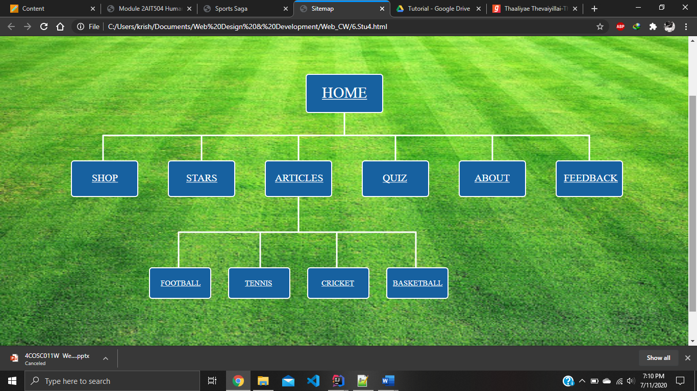

As shown in the figure the sitemap was designed to a hierarchical structure using rectangles and lines. Eleven rectangles were used to depict the web pages and the lines were used to depict the connection between pages. The rectangles and the texts are grouped into one in order to display the text over a rectangle. The rectangles were given a reasonable height and width alongside with a border.

<g>

<rect class="home" id="home" width="150" height="75" x="600" y="80" rx="5" onmouseover="mouseOverH()" onmouseout="mouseOutH()"/>

<text x="631" y="126" onmouseover="mouseOverH()" onmouseout="mouseOutH()"><a class="hometext" id="hometext" href="../Abdullah/home.html"> HOME </a></text>

</g>

As shown in the snippet the rectangle and text were grouped into one. For each web page a group was formed with a rectangle and a text. Each one of them was given an id and a class. Class was used to style the elements and the id was used for mouse over and mouse out events.

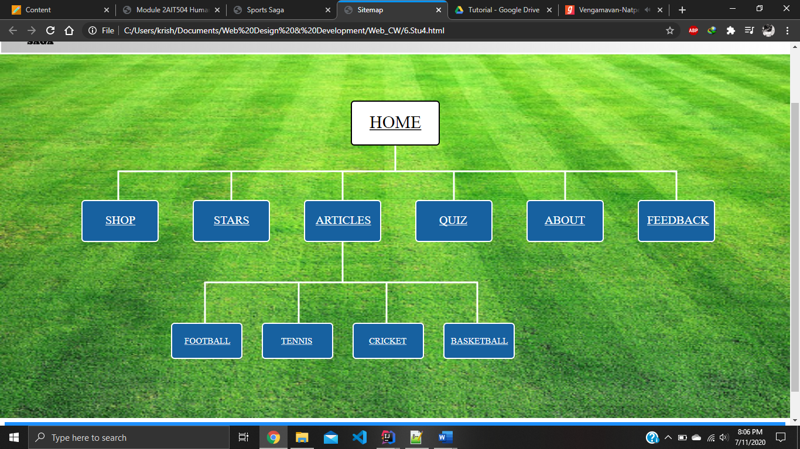

As shown in the figure mouse over and mouse out events were used to enhance the user experience. Hover effect was not used as the color of the rectangle cannot be changed if the user brings the cursor over the text. So, on mouse over and on mouse out events were used on the rectangle and text as shown in the figure below.

function mouseOverH() {

document.getElementById("home").style.fill="white";

document.getElementById("hometext").style.fill="black";

document.getElementById("home").style.stroke="black";

}

function mouseOutH() {

document.getElementById("home").style.fill="#1761A0";

document.getElementById("hometext").style.fill="white";

document.getElementById("home").style.stroke="white";

}

Each event has a function and was added in the appropriate rectangle and text.

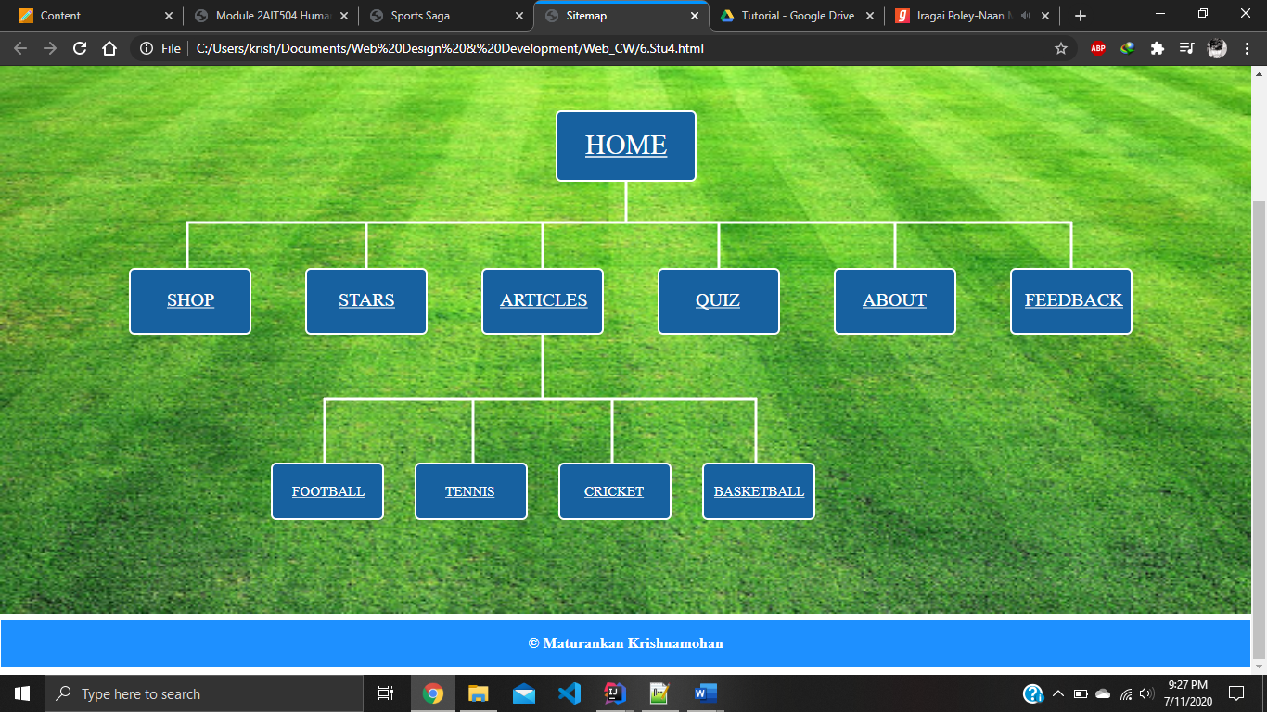

Link to the page editor was given in the footer of the page. It contains the details of the person who designed this page.

It was difficult to align the svg elements in the right place but after placing one element it was quite easy to place others.

View images and change background/text colour

This web page was designed for the users to view images. It contains five thumbnail images and when a user clicks on an image a larger image will be displayed alongside with the description of the image.

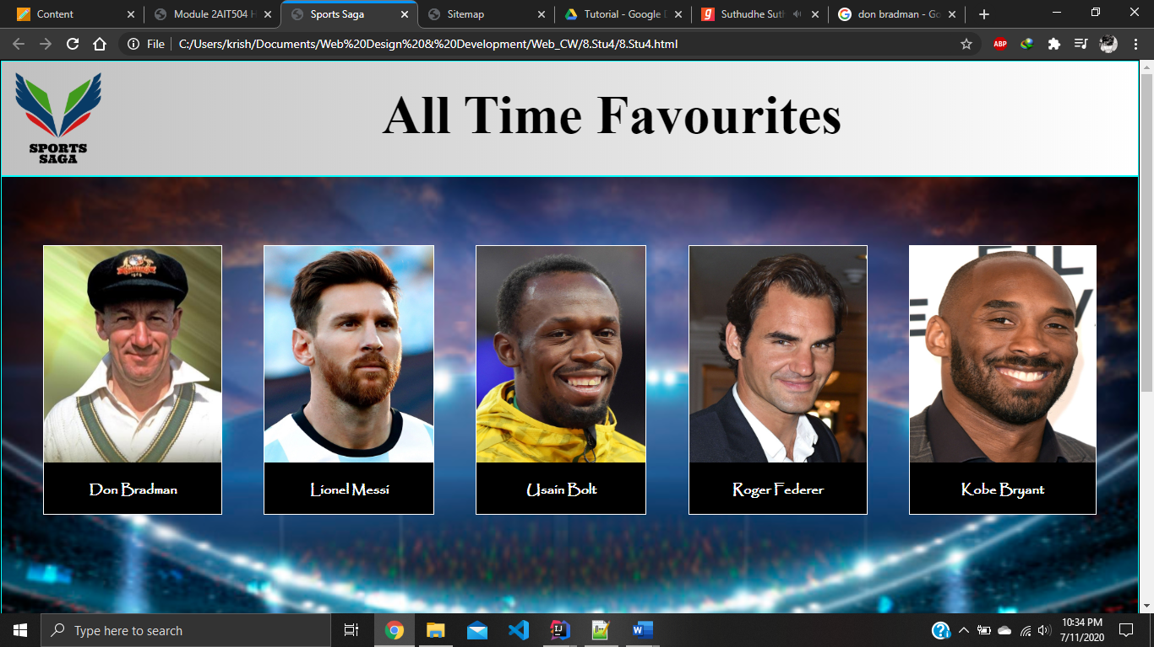

As shown in the figure the page contains five thumbnail images. Grid layout was used to align the images. Images are justified evenly to have a better look. Following code snippet shows how they are added in a grid.

div#picContainer {

display: grid;

grid-template-columns: auto auto auto auto auto;

justify-content: space-evenly;

padding-top: 6%;

}

When the user clicks on one of the images a larger image and a description of that image will be displayed in an area on the web page.

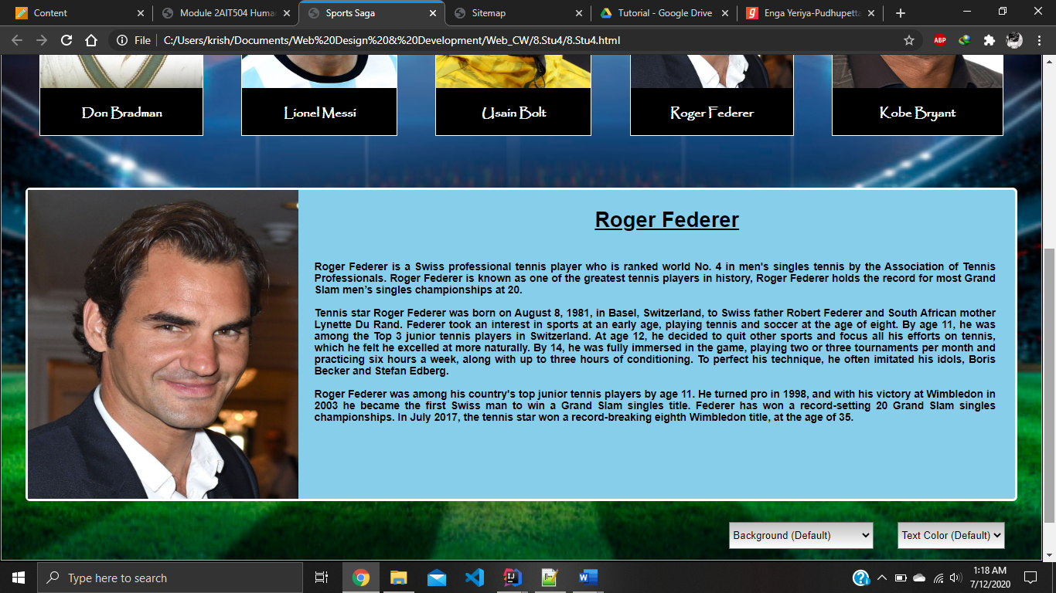

It was done using five separate divisions, each having a none display. When user clicks one image that particular image’s division will become as block display and will be displayed in the area allocated for the larger image and description. On click event was used to implement this function. When using none display method the divisions would not take up any space until the user clicks on an image. The following code snippet will show how it was done.

document.getElementById("description1").style.display="none";

document.getElementById("description2").style.display="none";

document.getElementById("description3").style.display="none";

document.getElementById("description4").style.display="none";

document.getElementById("description5").style.display="none";

Initially all the description divisions will be with the display none. But when an on click event occurs the following code will be implemented.

document.getElementById("description2").style.display="none";

document.getElementById("description3").style.display="none";

document.getElementById("description4").style.display="none";

document.getElementById("description5").style.display="none";

document.getElementById("blank").style.display="none"

document.getElementById("description1").style.display="block";

Only the corresponding division will become visible and all the others will be disappeared. All the divisions are allocated with separate id for this purpose.

Also, the user can the background and the text color of the web page using the drop-down menu provided below the larger image and the description. Three options were given for the background and two for the text color, there’re totally 4 backgrounds and 3 text colors available for the user to experience. On change event was used for this purpose, when the user changes the background or the color the corresponding changes will occur to the web page. Background and text colors are declared in javascript since it is easy to override. The following screenshot show how things will be when a user plays around with the background and text.

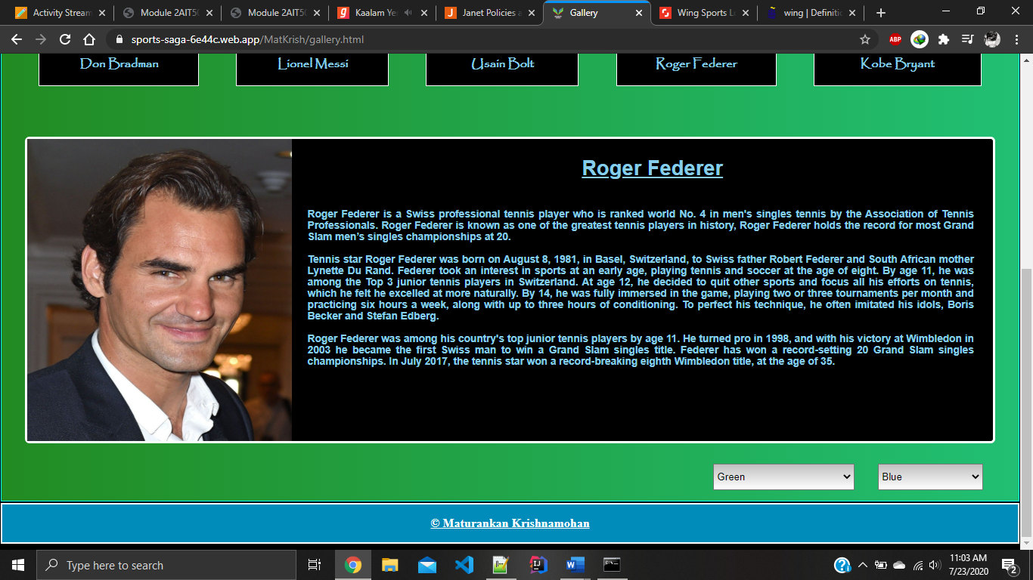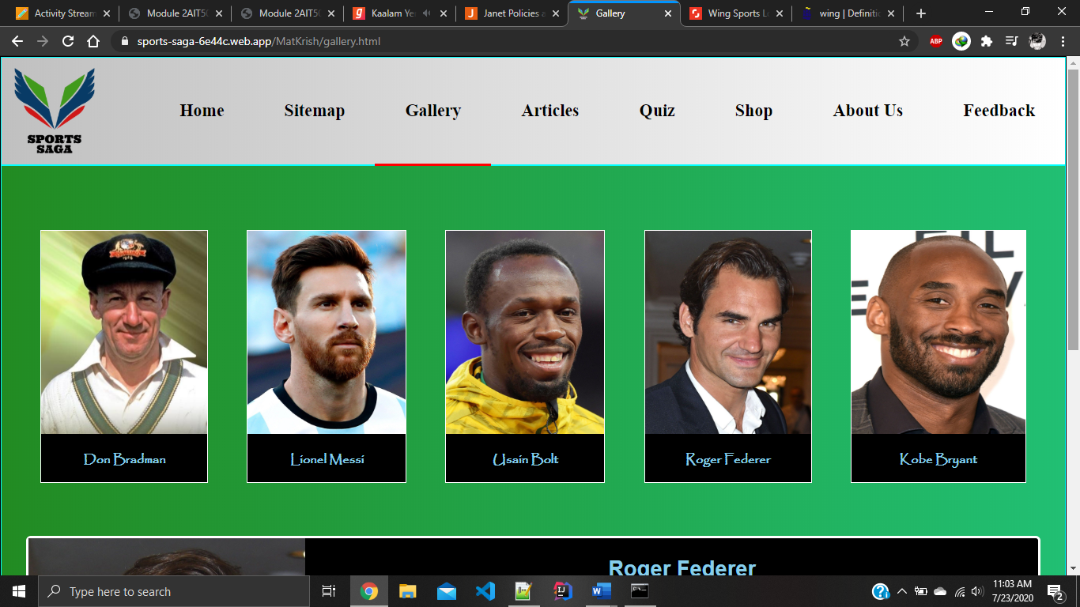

This is what the output will be when the user selects green as the background color and blue as the text color. If conditions and for loops were used to implement these functionalities efficiently. The following code snippets will show how they were implemented.

document.getElementById("blank").style.color="rgb(24,60,19)";

var x=document.getElementById("parentDescription").querySelectorAll

(".childDescription");

var i;

for (i=0;i<x.length;i++) {

x[i].style.backgroundColor="black";

x[i].style.color="skyblue";

}

var y=document.getElementById("container").querySelectorAll("#name");

var j;

for (j=0;j<y.length;j++) {

y[j].style.color="skyblue";

}

This snippet shows how the text color changes when a user changes the color. First the value of the pull-down menu was identified and then compared to each of the colors given using if conditions. If the value matches any given colors the functions will work accordingly. All the text colors are changed including the heading. Query selector all was used to get all the elements with the class ‘childDescription’ under the id ‘parentDescription’. And then a for loop is used to loop through all the elements under that particular id since it takes only one element at a time.

document.getElementById("container").style.backgroundImage="none";

document.getElementById("container").style.backgroundImage="linear-gradient(to right, forestgreen, #21bf73)";

This snippet shows how the background color changes when the user changes the background color. The value of the pull-down menu was identified and then compared to each color using if conditions. If the value matches any given color the background will be changed accordingly. The page initially contains a background image, when user selects a different background the image display will become none and the particular color will be added to the background.

Article

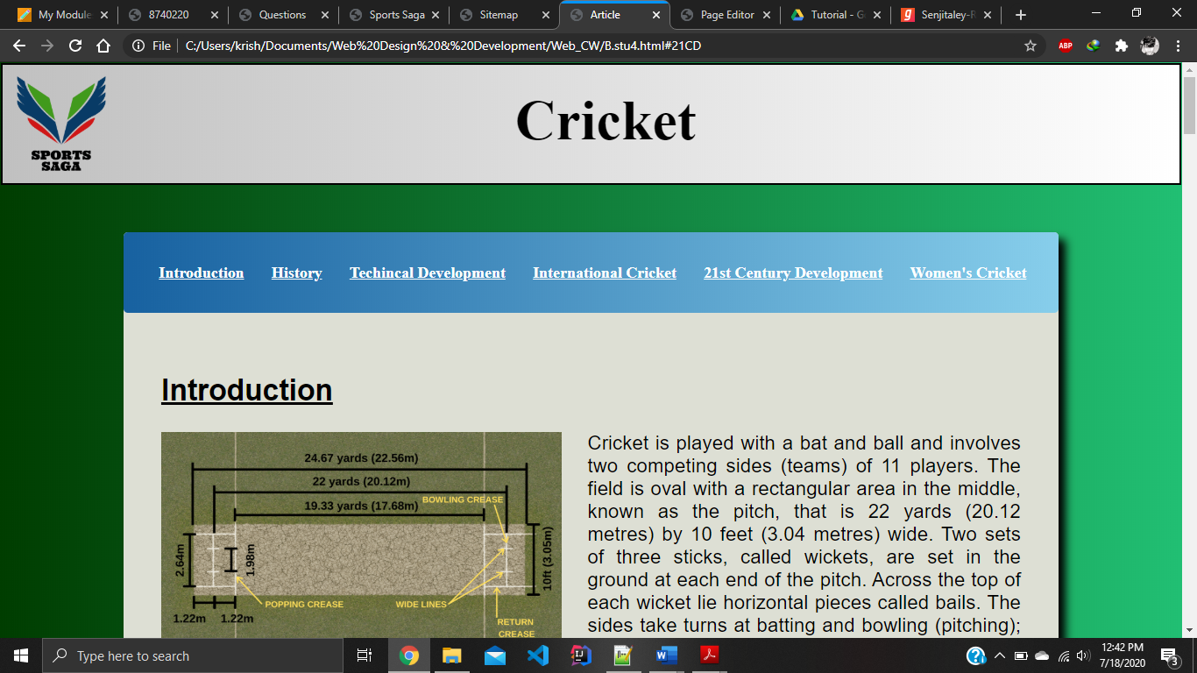

This page contains an article about cricket. This is a very simple page created using only html and css. Navigation bar is designed using unordered list and inline display is used to align the elements horizontally. Bullets are removed using list-style-type ‘none’. Remaining designs are made with proper padding and margin with proper color schemes.

Page Editor

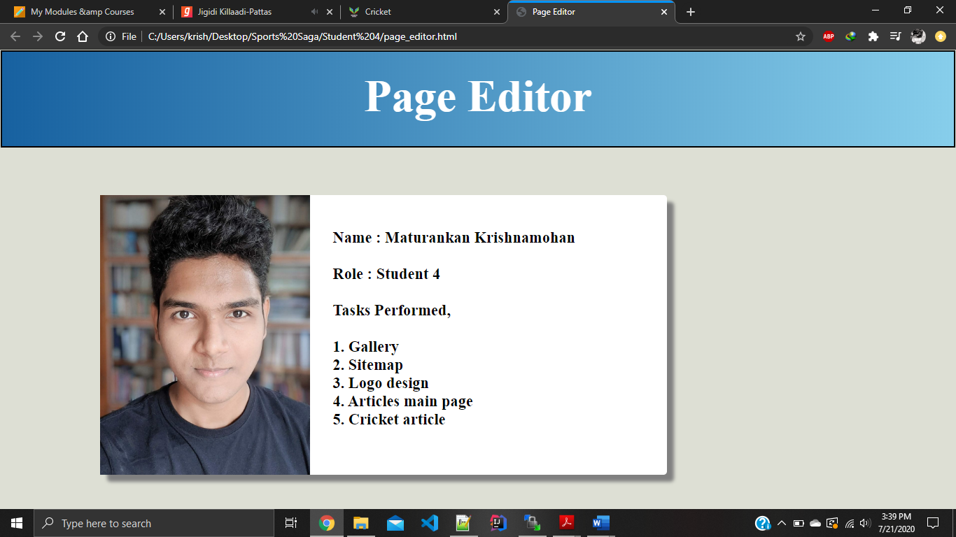

This page contains the details of the page editor. Name, role taken and tasks performed are included in the page. This page is external to the website and the link to this page is given in the footer of the web pages. A division with proper margin is used to design this page alongside with the image.

**Discussion of UI and application of UX principles**

Information Architecture

Website folders are structured according to the topic/subject. Each student’s work is categorized properly starting with the present page of student 1. Our website is structured around the home page like hierarchical structure. Website contains a navigation bar in the home page and in the second level pages. So, the user can easily navigate through the web pages without getting lost. The navigation bar contains a border which will show the user in which page he/she is, as shown in the following screenshot.

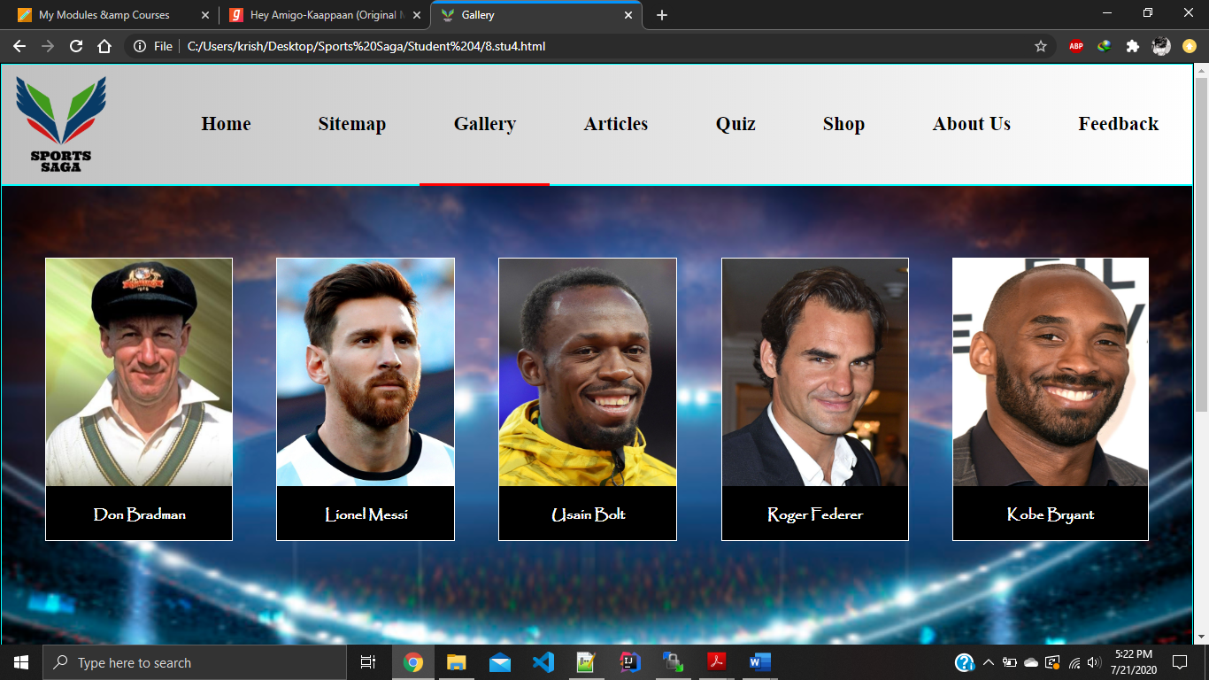

The following code snippets will show how this navigation bar was implemented.

<div id="navbar">

<a class="feedback"href="../Abdullah/comment.html">Feedback</a>

<a class="about"href="../Anzaf/author.html">About Us</a>

<a class="shop" href="../Ashwinth/Product_list.html">Shop</a>

<a class="quiz" href="../Anzaf/quiz.html">Quiz</a>

<a class="articles" href="articles.html">Articles</a>

<a class="gallery" href="gallery.html">Gallery</a>

<a class="sitemap"href="sitemap.html">Sitemap</a>

<a class="home" href="../Abdullah/home.html">Home</a>

</div>

div#navbar a:hover:not(.gallery) {

background-color: rgb(91,187,34);

color: white;

border-bottom: 3px solid red;

}

a.gallery {

border-bottom: 3px solid red;

}

div#navbar a {

color: black;

font-weight: bold;

text-align: center;

height: 42px;

padding: 38px;

padding-top: 4%;

text-decoration: none;

font-size: 22px;

float: right;

font-family: bahnshrift;

}

Css plays a major part in the navigation system as it is easy to guide the user using proper styling to the navigation bar. Hover effect won’t be applied to the page where the user is at. It also has a border to indicate the current page as said above.

Third level of the website contains articles about sports. It contains a certain navigation system to guide the user through the article.

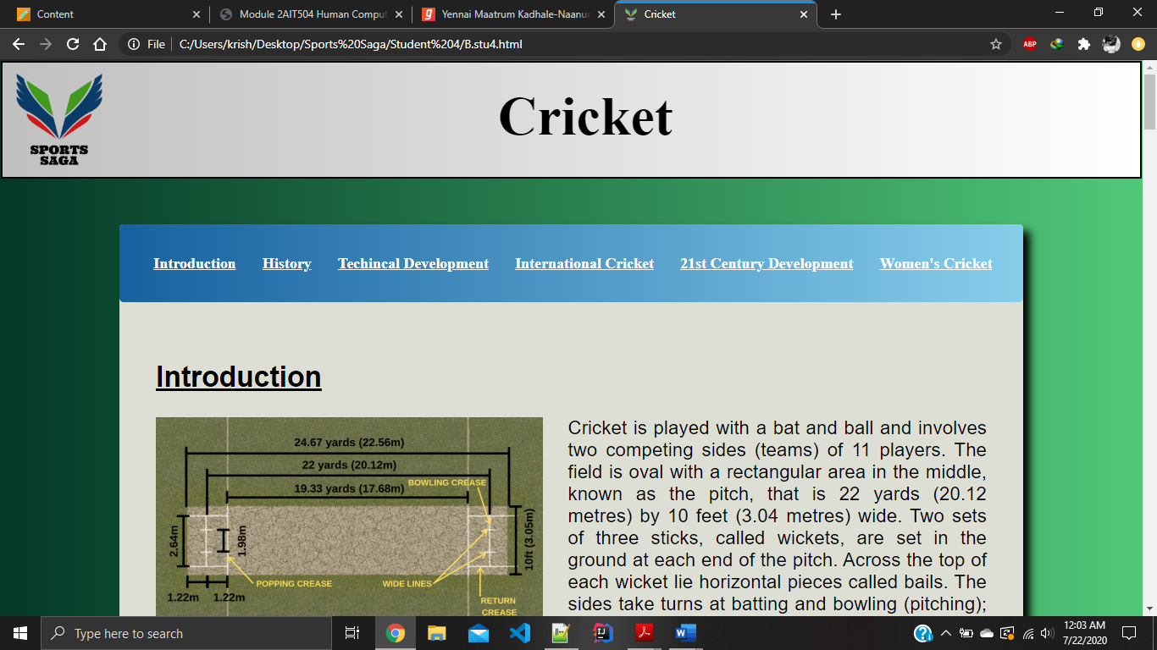

As shown in the screenshot anchors are used in the article to aid the user, so that user doesn’t need to scroll down all the way down to read his/her interested topic. The following code snippet will show how this was implemented.

<ul>

<li><a href="#intro">Introduction</a></li>

<li><a href="#history">History</a></li>

<li><a href="#TD">Techincal Development</a></li>

<li><a href="#IC">International Cricket</a></li>

<li><a href="#21CD">21st Century Development</a></li>

<li><a href="#WC">Women's Cricket</a></li>

</ul>

ul{

list-style-type: none;

border-radius: 5px;

background-image: linear-gradient(to right, #1761A0, skyblue) ;

height: 60px;

padding-top: 3%;

}

li {

display: inline;

padding-right: 2.5%;

font-size: 80%;

font-weight: bold;

}

As shown in the figure display inline property was used to create a horizontal navigation bar and list-style-type none is used to remove the bullets of the list. A hover effect is added to help the user to identify the navigation system.

Site Organization

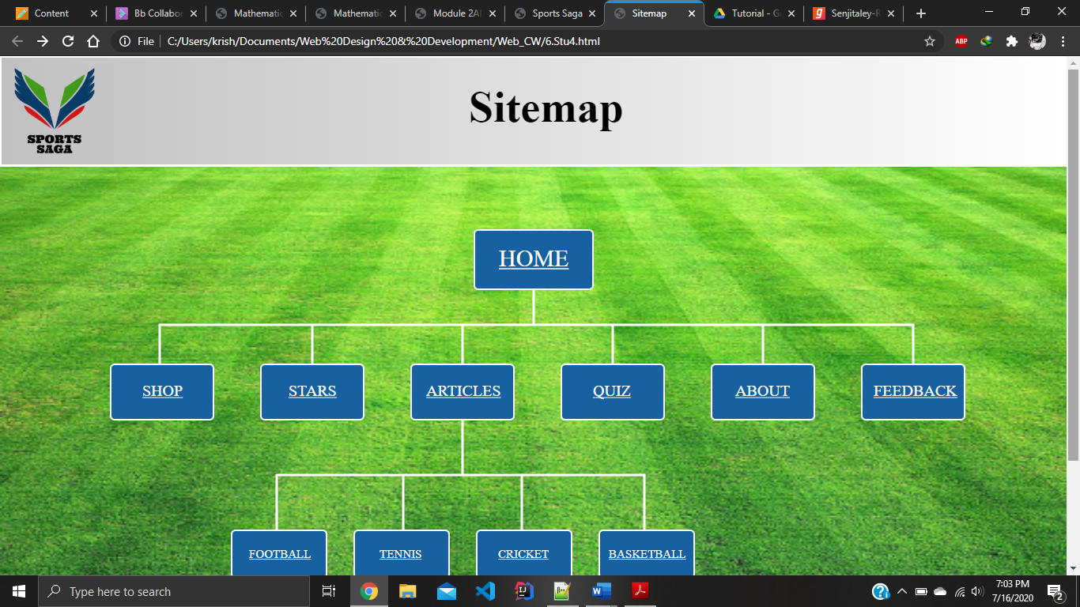

Our website follows a hierarchical structure, so the sitemap was designed accordingly. Website contains a homepage with two levels. Main section contains all the main pages and the sub level contains articles related to a particular topic. But we have given the user the ability to navigate to different pages.

Code to achieve good information architecture

<!-- Division to display header -->

<div id="header">

<a href="../Abdullah/home.html"> <img id="logo" src="logo7.png" alt="logo"> </a>

<!-- Division to display navigation bar -->

<div id="navbar">

<a class="feedback"href="../Abdullah/comment.html">Feedback

</a>

<a class="about"href="../Anzaf/author.html">About Us</a>

<a class="shop" href="../Ashwinth/Product_list.html">Shop</a>

<a class="quiz" href="../Anzaf/quiz.html">Quiz</a>

<a class="articles" href="articles.html">Articles</a>

<a class="gallery" href="gallery.html">Gallery</a>

<a class="sitemap"href="sitemap.html">Sitemap</a>

<a class="home" href="../Abdullah/home.html">Home</a>

</div>

</div>

<div id="container">

<!-- Main division which includes the whole content -->

</div>

<div id="footer">

<!-- Division to display footer -->

</div>

This is the common format used for my web pages.

Color balance & graphics consistency

Our website was created using cool colors. Green and blue are the major colors as green represents the platform where most of the sports are played and blue is a one of the major sporty color.

Gallery page mainly concentrates on blue color since it discusses about athletes. Blue represents professionalism, honor & stability. Color contrasts are tested well before applying these colors. This page has a ground as a background image with the major color as blue. It contains green as a minor part. A sports ground is chosen as the background as our website is about sports. Texts are written over a ‘skyblue’ background in black color as shown in the following screenshot.

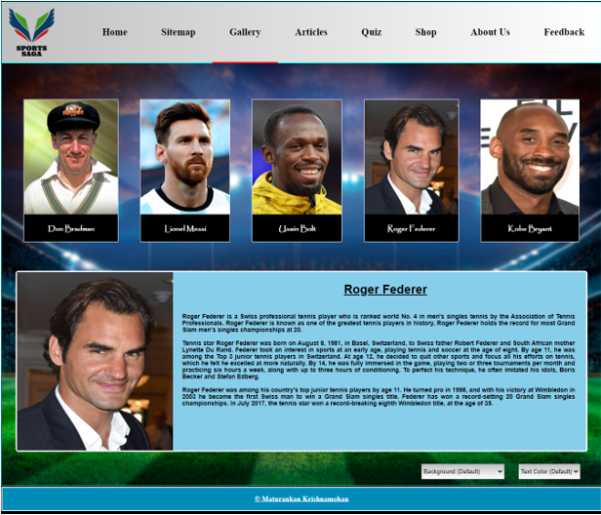

Sitemap has green color as the major color with some blue color. Even in this page sports ground is used as the background but this time it’s green. Texts are written over a blue color background. Color contrasts are tested well before applying these. SVG lines are white as it symbolizes the white lines drawn on the grounds to assist players and follow the rules.



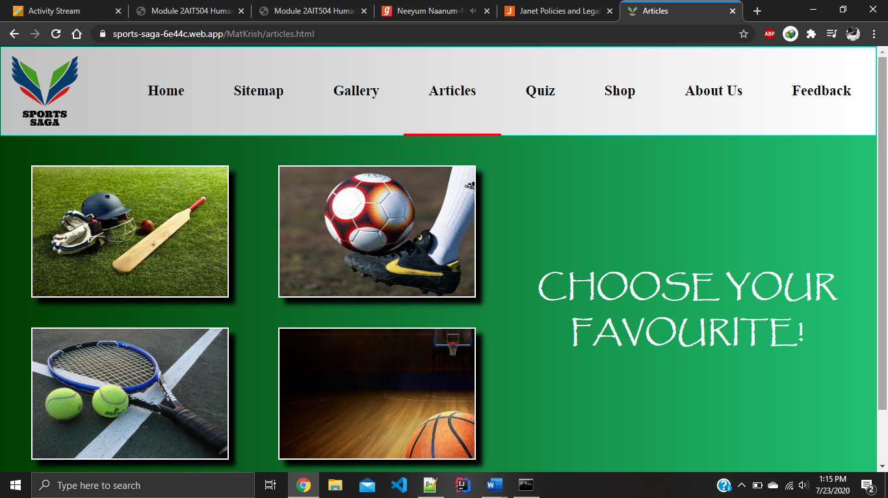Article page too follows the above said themes.

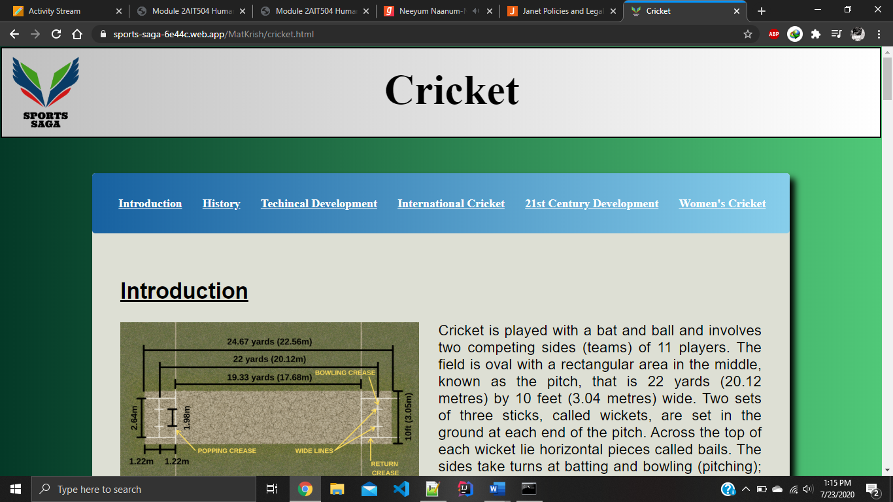

The main colors of our website are inspired from our website logo as its main colors are blue and green.



Header consists of silver and white color and footer is blue in color. They both contrast well for our background color choices which are blue and green.

Code to achieve good color balance

Gallery page was challenging to achieve good color balance as I had to use different colors to the page so that user can change it. From right to left the color varies so that user won’t feel uncomfortable to the sudden color change. The following code snippets will show how it was achieved.

"linear-gradient(to right, #1761A0, skyblue)"

"linear-gradient(to right, #a61919, #c70039)"

“linear-gradient(to right, forestgreen, #21bf73)”

Even our website header follows the same protocol. To assist that we have our background colors as gradient too.

div#header {

background-image: linear-gradient(to right, silver , white);

}

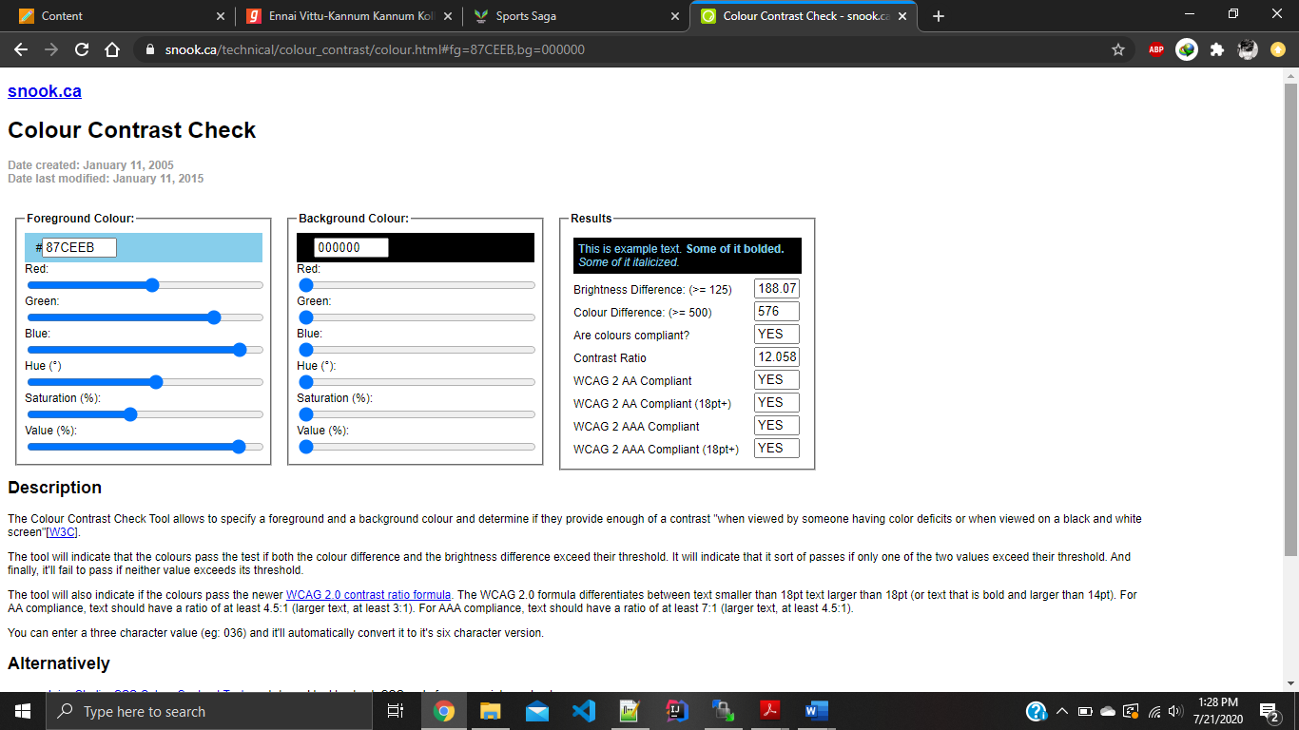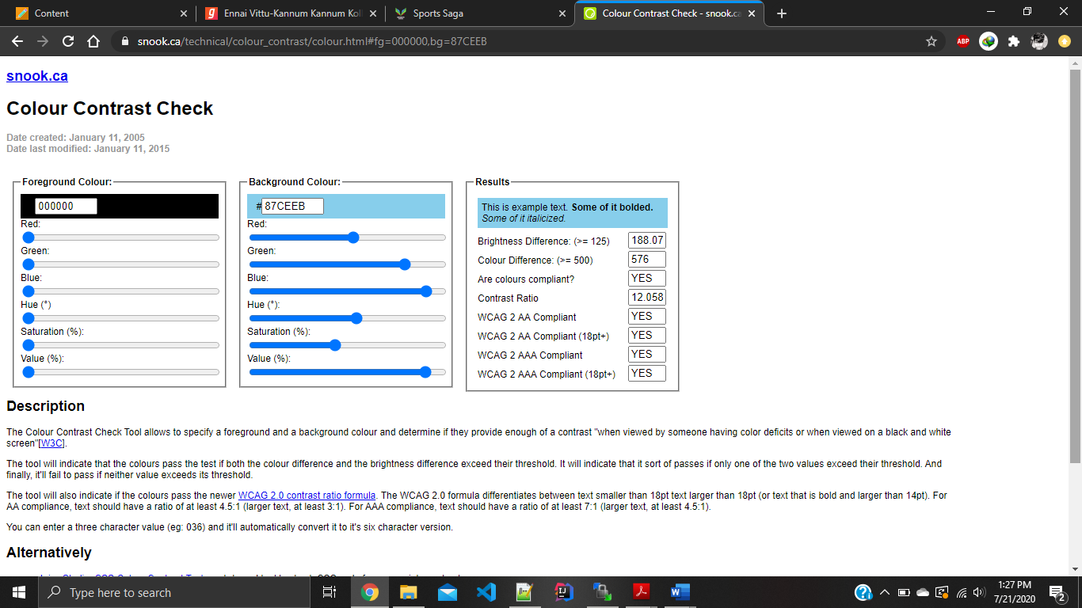Color contrast test results

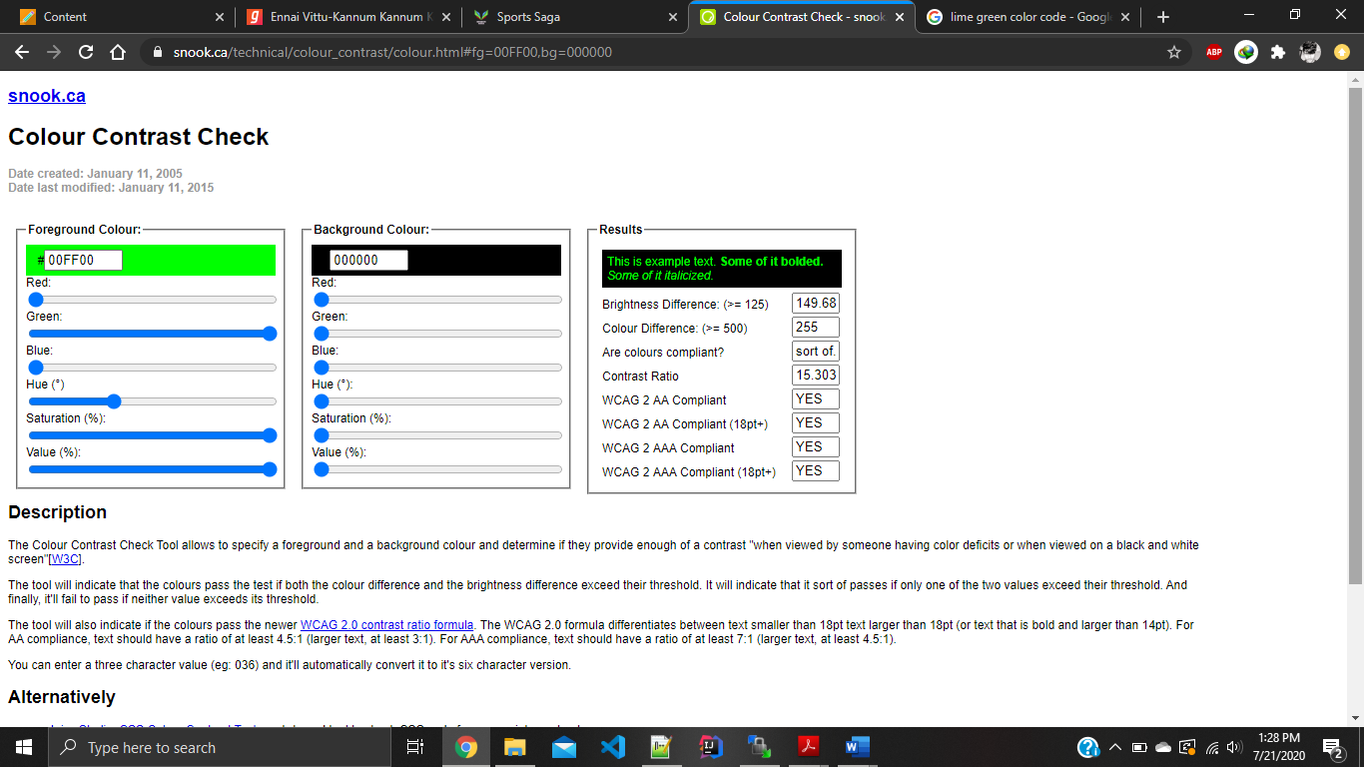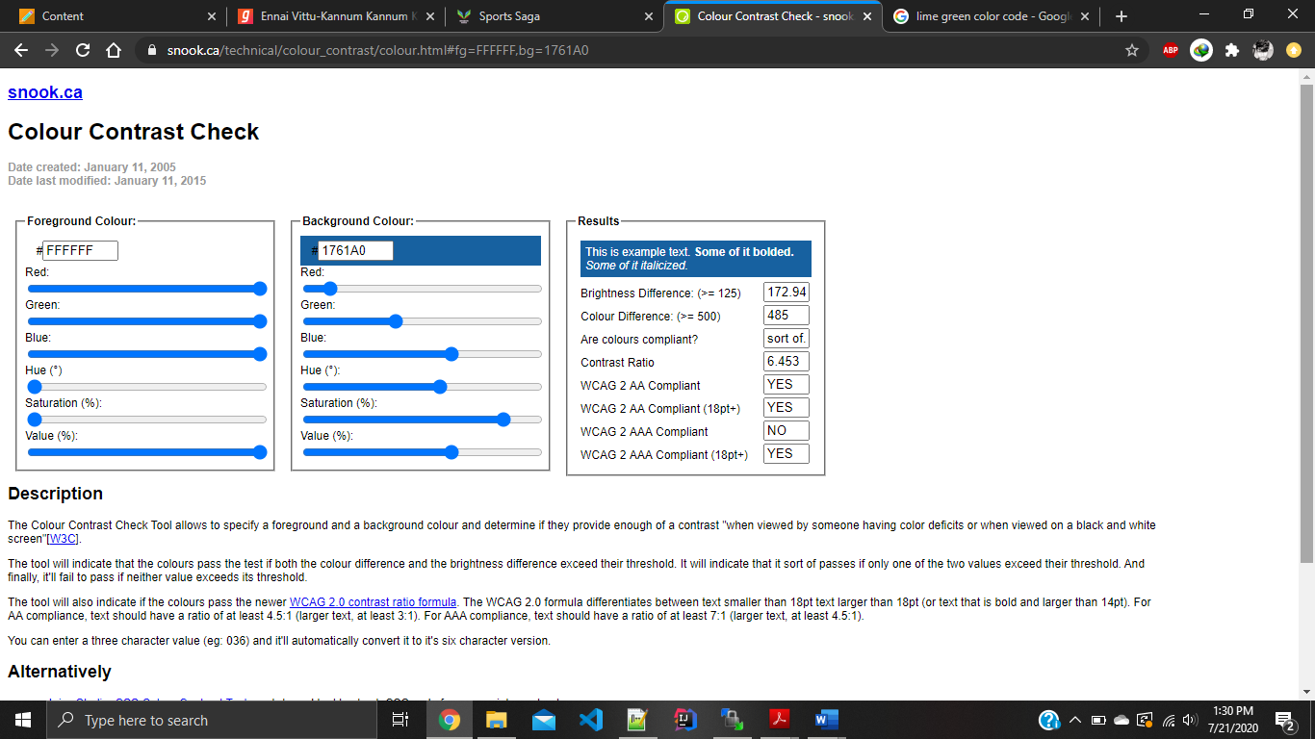

**Typography**

Gallery page contains two types of fonts, Papyrus and Helvetica. Papyrus is used to style the names of the athletes while Helvetica is used in the descriptions of the athletes. 1% viewport width is used for the descriptions and 2% viewport width is used for the heading which is the name of an athlete. Default font size is used in the name section under the photos of each athlete. This is applied to all the divisions of the larger image and descriptions. Headings and descriptions are in perfect symmetry.

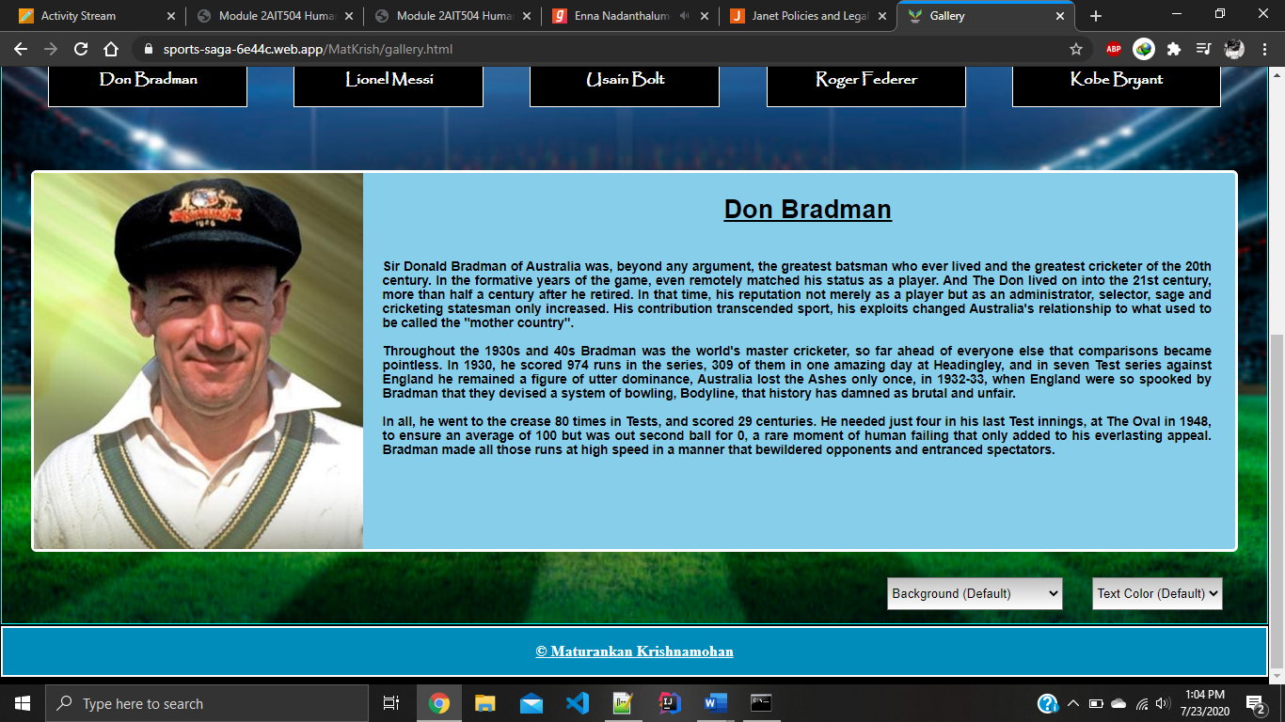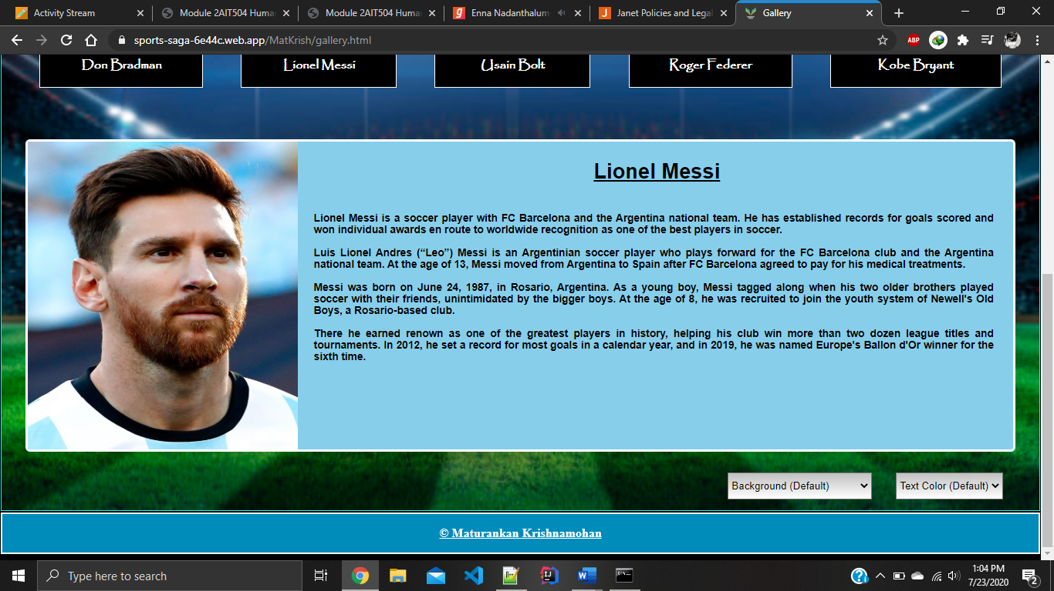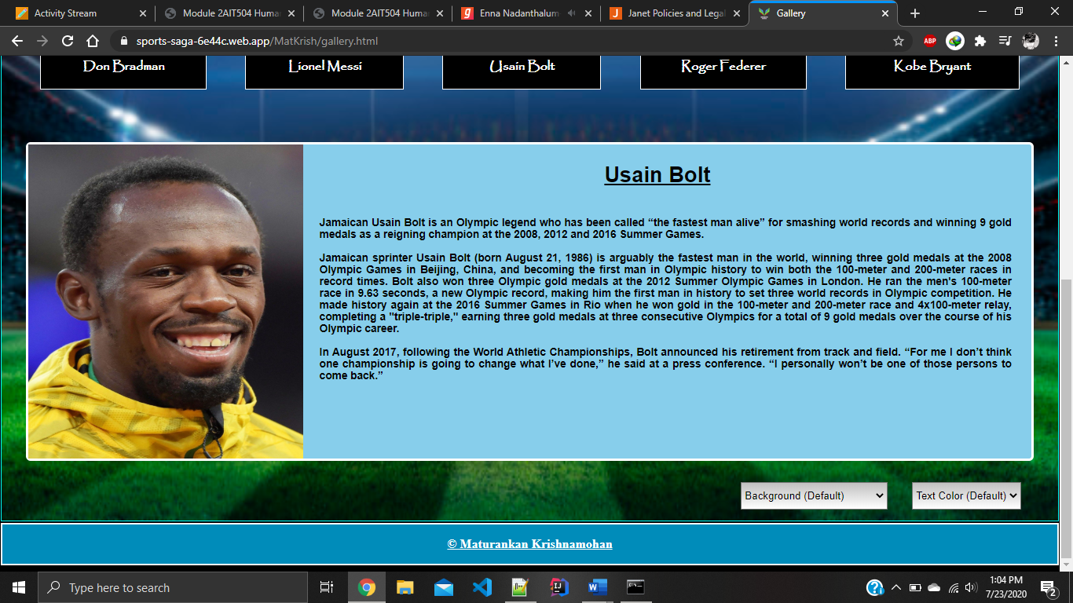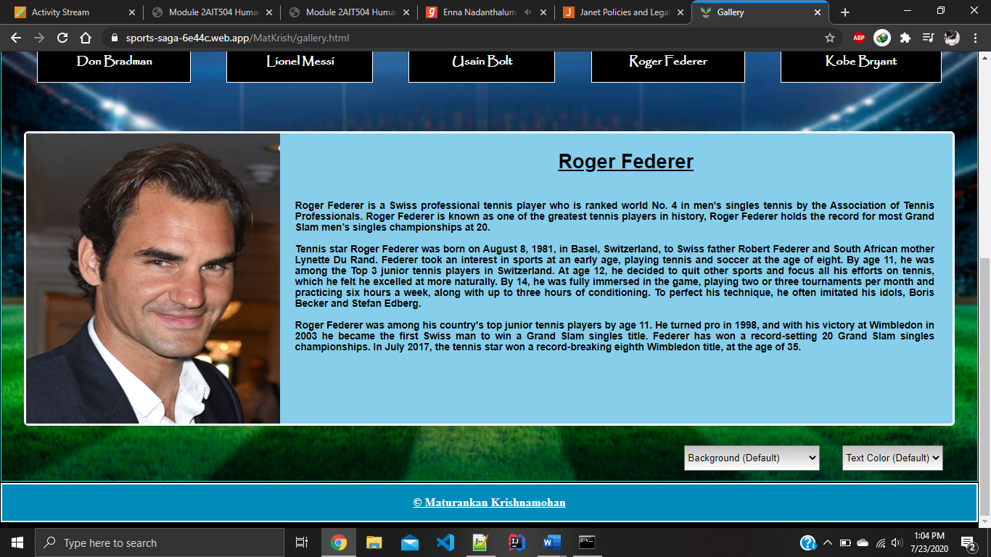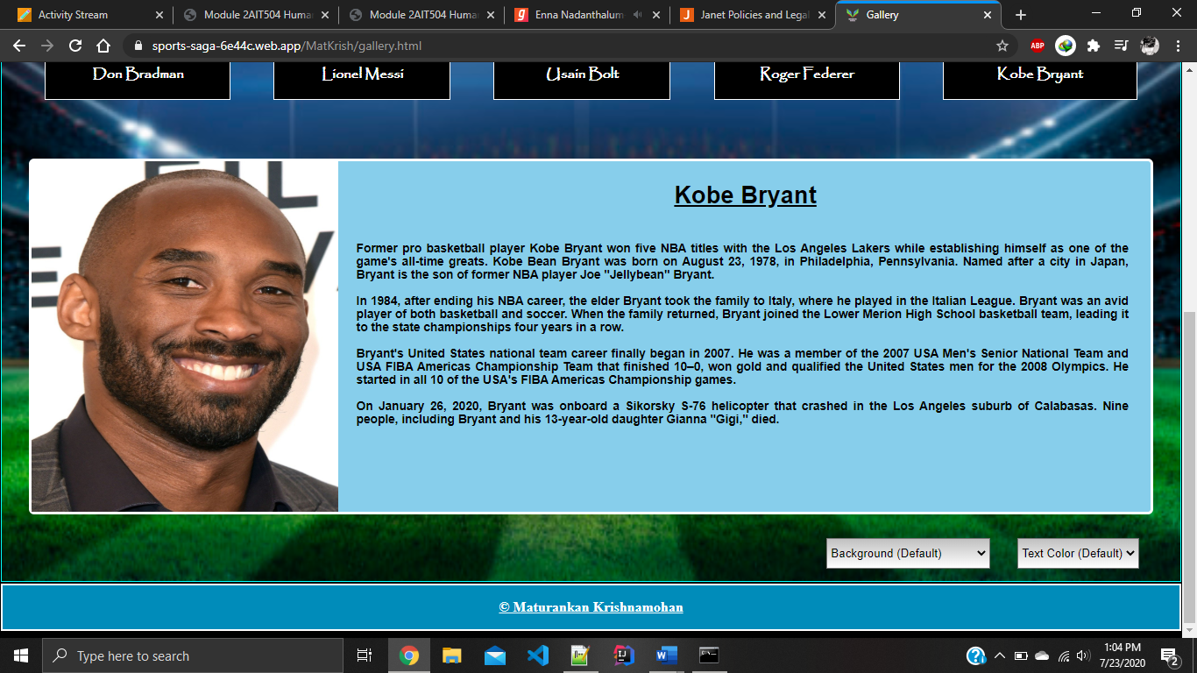

Use of papyrus font,

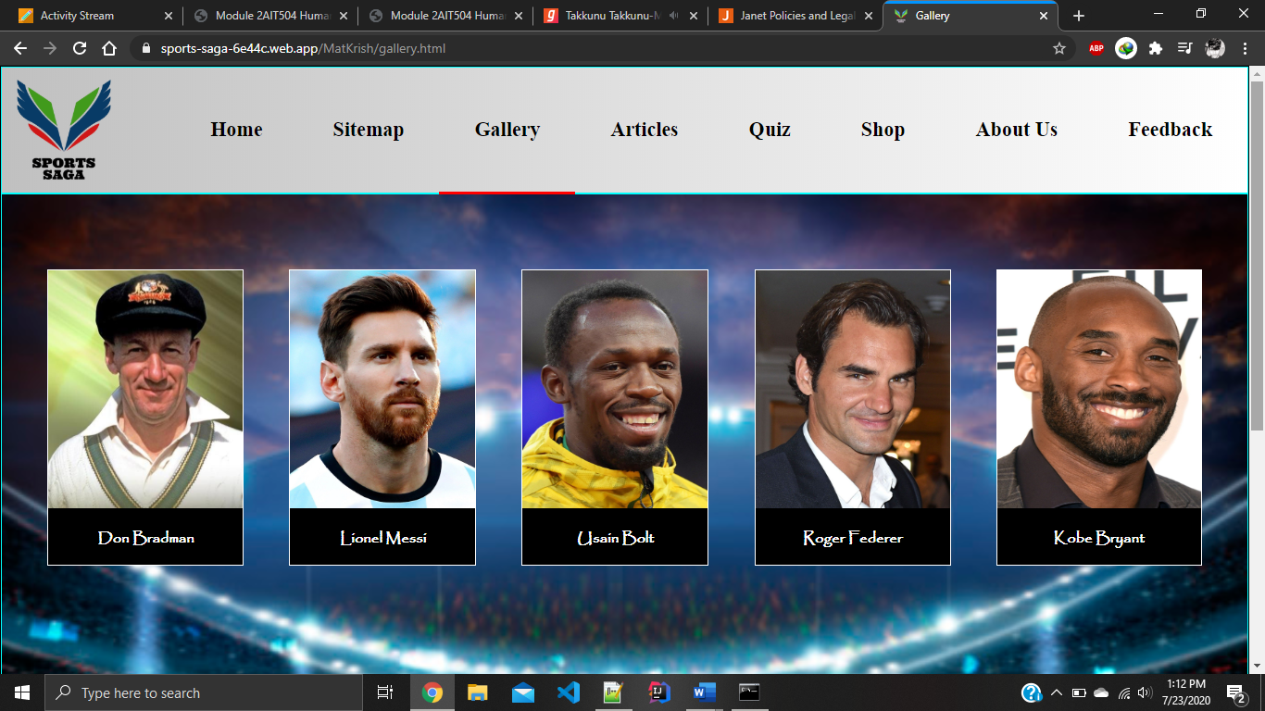

Sitemap contains default fonts as the use of fonts are much lesser in that page.

Article main page has papyrus font to convey the information. Default font is used in the images when user interacts with them.

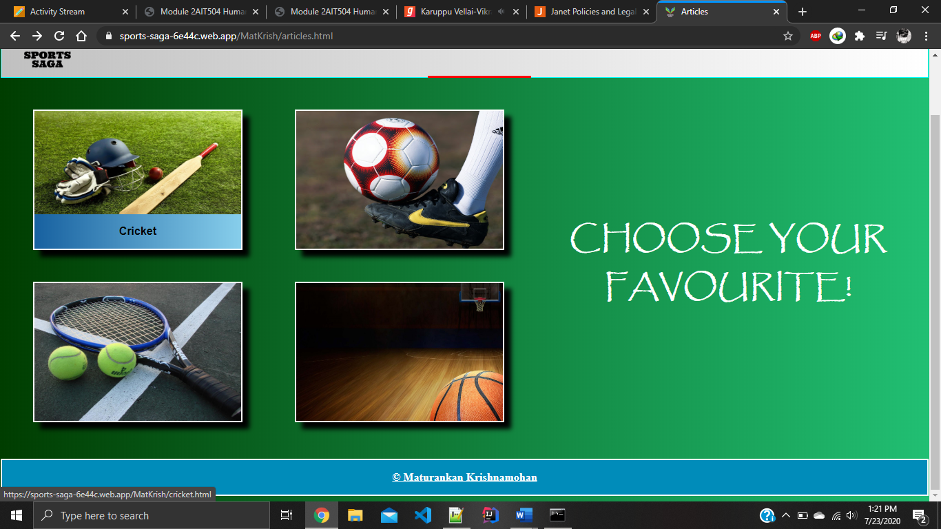

Cricket article contains many headings and paragraphs. Helvetica is used as the font but the font size varies. Heading font is larger than others.

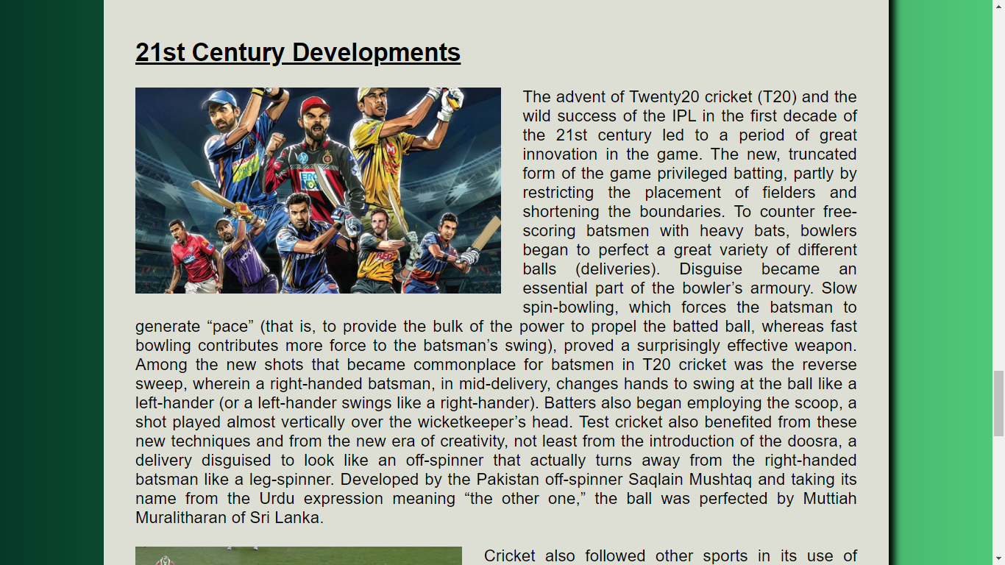

Code to achieve good consistency

“font-size: 1vw;” is used to change the font size in the gallery page descriptions.

“font-family: Helvetica;” & “font-family: papyrus;” are used to change the font style of the pages.

Legibility of the web pages were checked using an online tool. Following screenshots will show the results. Gallery page and article page were tested as they are only one with lot of texts.

Gallery page,

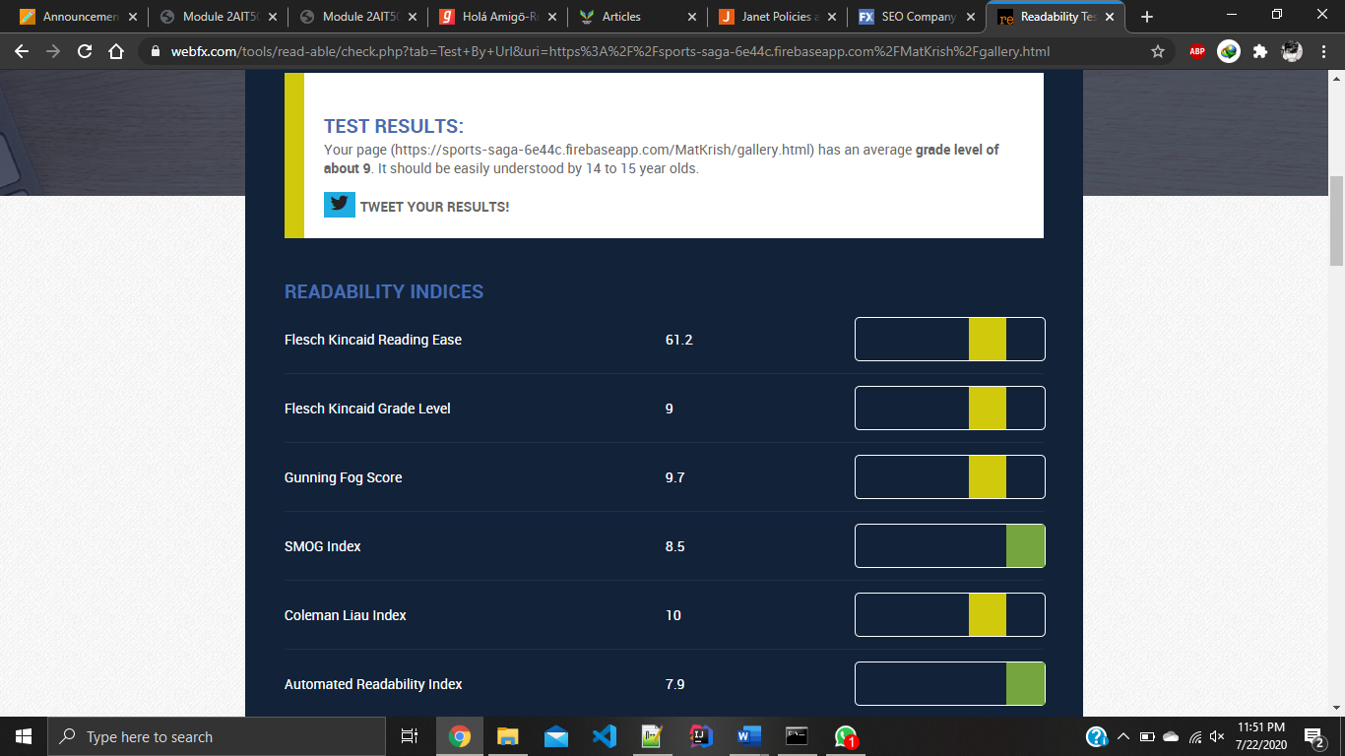

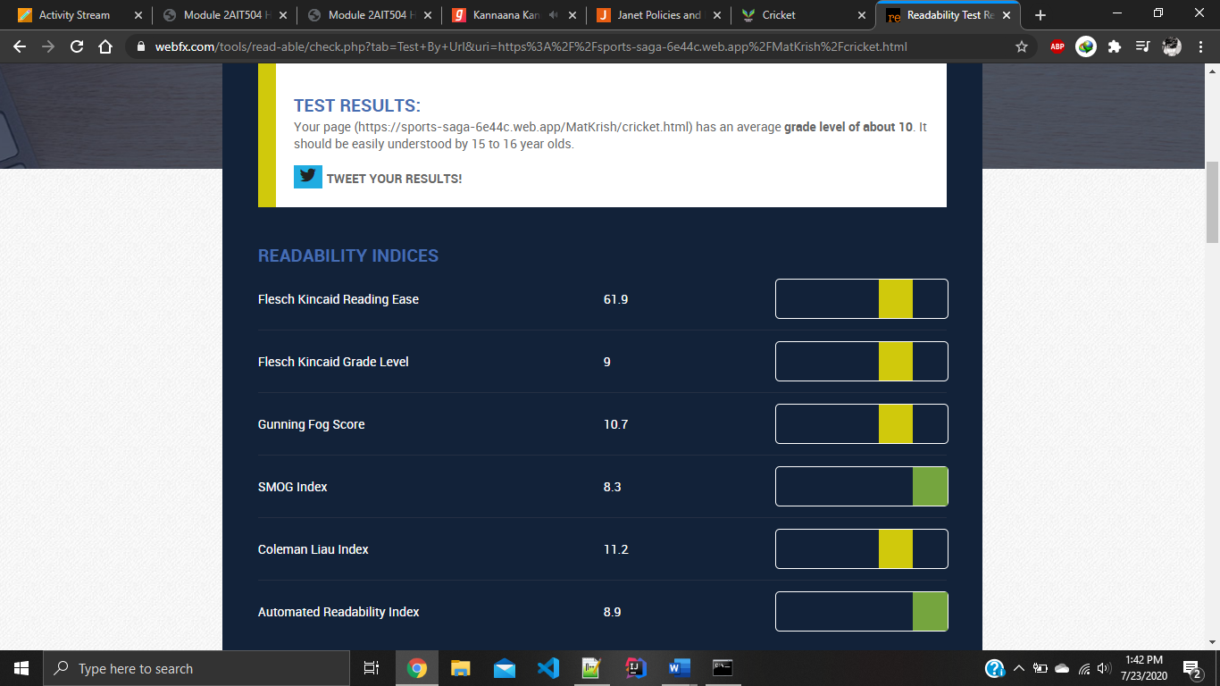Cricket article page,

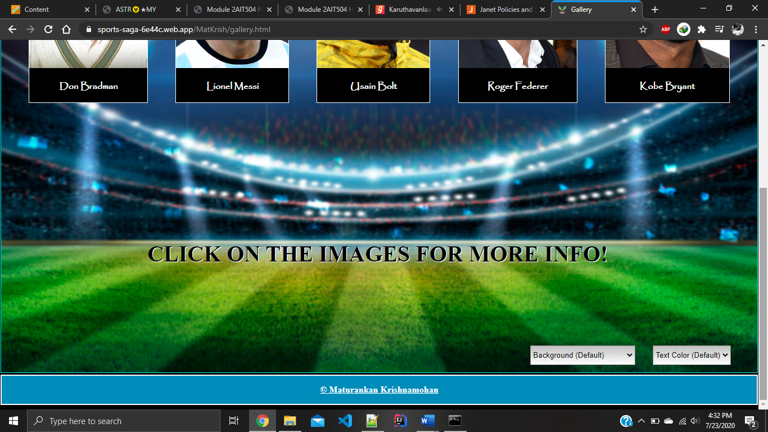Gestalt principle

As shown in the image the page consists of 5 images. They are grouped together as a grid. A user can easily tell that these images belong to the same content group. In case if the user doesn’t know what to do in this page, I have guided them using the instruction ‘click on the images for more info’. And I have given the name of each athlete under the images grouped as one division.



As in the above image description also grouped with image, heading and a paragraph. It is visible as a group since I have allocated a division for the image and description. Heading and paragraphs are justified so that the group will look like even. Drop down menus are easily identifiable as I have written ‘background’ and ‘text color’ in them.



In the sitemap I have used on mouse over and on mouse out events to assist the user that the boxes are clickable. Text and rectangles are grouped as one as shown in the figure.

Accessibility

I have added ‘alt’ for the images so the user can see what was supposed be there even if the image was not available.

<img id="bimgrk" src="roger.jpg" alt="Roger Federer">

There were no further graphical elements were used in my web pages.

Error Prevention

Forms were not a part of my web pages so I didn’t get a chance to interact with the user. There will be no errors occurring in my web pages.

Conclusion

It was difficult to work as a team to develop one website as we all had different ideas and styles. Though it was difficult we managed to pull off as a team by having clear ideas about what our roles are.

References

cricket.html page

https://www.britannica.com/

The references of for the article were taken from the above website

https://www.wikipedia.org/

The references of for the article were taken from the above website

Images used for the pages.

https://www.freepik.com/

The images used for the entire website were taken from the above link

This website is a free source website

Code

gallery.html

<!DOCTYPE html>

<html>

<head>

<link rel="icon" href="favicon.png">

<link rel="stylesheet" href="gallery.css">

<meta name="viewport" content="width=device-width, initial-scale=1.0">

<title>

Gallery

</title>

</head>

<body>

<!-- Division to display header -->

<div id="header">

<a href="../Abdullah/home.html"> <img id="logo" src="logo7.png" alt="logo"> </a>

<!-- Division to display navigation bar -->

<div id="navbar">

<a class="feedback"href="../Abdullah/comment.html">Feedback</a>

<a class="about"href="../Anzaf/author.html">About Us</a>

<a class="shop" href="../Ashwinth/Product_list.html">Shop</a>

<a class="quiz" href="../Anzaf/quiz.html">Quiz</a>

<a class="articles" href="articles.html">Articles</a>

<a class="gallery" href="gallery.html">Gallery</a>

<a class="sitemap"href="sitemap.html">Sitemap</a>

<a class="home" href="../Abdullah/home.html">Home</a>

</div>

</div>

<!-- Main division which includes the whole content -->

<div id="container">

<!-- Division to display all five images -->

<div id="picContainer">

<!-- Division to display an image with the name -->

<div id="common" onclick="don()">

<img id="img5" src="don.jpg" alt="Don Bradman">

<P id="name" class="childDescription"> Don Bradman </p>

</div>

<!-- Division to display an image with the name -->

<div id="common" onclick="messi()">

<img id="img1" src="messi.jpg" alt="Lionel Messi">

<p id="name" class="childDescription"> Lionel Messi </p>

</div>

<!-- Division to display an image with the name -->

<div id="common" onclick="bolt()">

<img id="img4" src="bolt.jpg" alt="Usain Bolt">

<p id="name" class="childDescription"> Usain Bolt </p>

</div>

<!-- Division to display an image with the name -->

<div id="common" onclick="roger()">

<img id="img2" src="roger.jpg" alt="Roger Federer">

<p id="name" class="childDescription"> Roger Federer </p>

</div>

<!-- Division to display an image with the name -->

<div id="common" onclick="kobe()">

<img id="img3" src="kobe.jpg" alt="Kobe Bryant">

<p id="name" class="childDescription"> Kobe Bryant </p>

</div>

</div>

<form>

<!-- Division to display the information -->

<div id="blank">

<p id="blank">CLICK ON THE IMAGES FOR MORE INFO!</p>

</div>

<div id="parentDescription">

<!-- Division to display the contents of Lionel Messi -->

<div id="description1" class="childDescription">

<img id="bimgmdu" src="messi.jpg" alt="messi">

<h2 class="childDescription"> Lionel Messi </h2>

<p id="desM" class="childDescription">

<br>Lionel Messi is a soccer player with FC Barcelona and the Argentina national team.

He has established records for goals scored and won individual awards en route to worldwide recognition

as one of the best players in soccer. <br><br>

Luis Lionel Andres (“Leo”) Messi is an Argentinian soccer player who plays forward for the FC Barcelona

club and the Argentina national team. At the age of 13, Messi moved from Argentina to Spain after FC Barcelona

agreed to pay for his medical treatments. <br><br>

Messi was born on June 24, 1987, in Rosario, Argentina. As a young boy, Messi tagged along when his two older brothers

played soccer with their friends, unintimidated by the bigger boys. At the age of 8, he was recruited to join the youth

system of Newell's Old Boys, a Rosario-based club. <br><br>

There he earned renown as one of the greatest players in history, helping his club win more than two dozen league

titles and tournaments. In 2012, he set a record for most goals in a calendar year, and in 2019, he was named Europe's

Ballon d'Or winner for the sixth time. <br><br>

</p>

</div>

<!-- Division to display the contents of Don Bradman -->

<div id="description2" class="childDescription">

<img id="bimgmdu" src="don.jpg" alt="bradman">

<h2 class="childDescription"> Don Bradman </h2>

<p id="desD" class="childDescription">

<br>Sir Donald Bradman of Australia was, beyond any argument, the greatest batsman who ever lived and the greatest cricketer

of the 20th century. In the formative years of the game, even remotely matched his status as a player.

And The Don lived on into the 21st century, more than half a century after he retired. In that time, his reputation not

merely as a player but as an administrator, selector, sage and cricketing statesman only increased. His contribution

transcended sport, his exploits changed Australia's relationship to what used to be called the "mother country".<br><br>

Throughout the 1930s and 40s Bradman was the world's master cricketer, so far ahead of everyone else that comparisons became

pointless. In 1930, he scored 974 runs in the series, 309 of them in one amazing day at Headingley, and in seven Test series

against England he remained a figure of utter dominance, Australia lost the Ashes only once, in 1932-33, when England were so

spooked by Bradman that they devised a system of bowling, Bodyline, that history has damned as brutal and unfair.<br><br>

In all, he went to the crease 80 times in Tests, and scored 29 centuries. He needed just four in his last Test innings, at The

Oval in 1948, to ensure an average of 100 but was out second ball for 0, a rare moment of human failing that only added to

his everlasting appeal. Bradman made all those runs at high speed in a manner that bewildered opponents and entranced spectators.<br><br>

</p>

</div>

<!-- Division to display the contents of Usain Bolt -->

<div id="description3" class="childDescription">

<img id="bimgmdu" src="bolt.jpg" alt="bolt">

<h2 class="childDescription"> Usain Bolt </h2>

<p id="desB" class="childDescription">

<br>Jamaican Usain Bolt is an Olympic legend who has been called “the fastest man alive” for smashing world records and winning 9

gold medals as a reigning champion at the 2008, 2012 and 2016 Summer Games. <br><br>

Jamaican sprinter Usain Bolt (born August 21, 1986) is arguably the fastest man in the world, winning three gold medals at the

2008 Olympic Games in Beijing, China, and becoming the first man in Olympic history to win both the 100-meter and 200-meter races

in record times. Bolt also won three Olympic gold medals at the 2012 Summer Olympic Games in London. He ran the men's 100-meter

race in 9.63 seconds, a new Olympic record, making him the first man in history to set three world records in Olympic competition.

He made history again at the 2016 Summer Games in Rio when he won gold in the 100-meter and 200-meter race and 4x100-meter relay,

completing a "triple-triple," earning three gold medals at three consecutive Olympics for a total of 9 gold medals over the course

of his Olympic career. <br><br>

In August 2017, following the World Athletic Championships, Bolt announced his retirement from track and field. “For me I don’t

think one championship is going to change what I’ve done,” he said at a press conference. “I personally won’t be one of those persons

to come back.” <br><br>

</p>

</div>

<!-- Division to display the contents of Roger Federer -->

<div id="description4" class="childDescription">

<img id="bimgrk" src="roger.jpg" alt="federer">

<h2 class="childDescription"> Roger Federer </h2>

<p id="desR" class="childDescription">

<br>Roger Federer is a Swiss professional tennis player who is ranked world No. 4 in men's singles tennis by the Association of Tennis

Professionals. Roger Federer is known as one of the greatest tennis players in history, Roger Federer holds the record for most Grand

Slam men’s singles championships at 20. <br><br>

Tennis star Roger Federer was born on August 8, 1981, in Basel, Switzerland, to Swiss father Robert Federer and South African mother

Lynette Du Rand. Federer took an interest in sports at an early age, playing tennis and soccer at the age of eight. By age 11, he was

among the Top 3 junior tennis players in Switzerland. At age 12, he decided to quit other sports and focus all his efforts on tennis,

which he felt he excelled at more naturally. By 14, he was fully immersed in the game, playing two or three tournaments per month and

practicing six hours a week, along with up to three hours of conditioning. To perfect his technique, he often imitated his idols,

Boris Becker and Stefan Edberg.<br><br>

Roger Federer was among his country's top junior tennis players by age 11. He turned pro in 1998, and with his victory at Wimbledon in

2003 he became the first Swiss man to win a Grand Slam singles title. Federer has won a record-setting 20 Grand Slam singles

championships. In July 2017, the tennis star won a record-breaking eighth Wimbledon title, at the age of 35. <br><br>

</p>

</div>

<!-- Division to display the contents of Kobe Bryant -->

<div id="description5" class="childDescription">

<img id="bimgrk" src="kobe.jpg" alt="bryant">

<h2 class="childDescription"> Kobe Bryant </h2>

<p id="desK" class="childDescription">

<br>Former pro basketball player Kobe Bryant won five NBA titles with the Los Angeles Lakers while establishing himself as one of the game's

all-time greats. Kobe Bean Bryant was born on August 23, 1978, in Philadelphia, Pennsylvania. Named after a city in Japan, Bryant is the

son of former NBA player Joe "Jellybean" Bryant.<br><br>

In 1984, after ending his NBA career, the elder Bryant took the family to Italy, where he played in the Italian League. Bryant was an avid

player of both basketball and soccer. When the family returned, Bryant joined the Lower Merion High School basketball team, leading it to

the state championships four years in a row. <br><br>

Bryant's United States national team career finally began in 2007. He was a member of the 2007 USA Men's Senior National Team and USA FIBA

Americas Championship Team that finished 10–0, won gold and qualified the United States men for the 2008 Olympics. He started in all 10 of

the USA's FIBA Americas Championship games. <br><br>

On January 26, 2020, Bryant was onboard a Sikorsky S-76 helicopter that crashed in the Los Angeles suburb of Calabasas. Nine people,

including Bryant and his 13-year-old daughter Gianna "Gigi," died. <br><br>

</p>

</div>

</div>

<!-- Drop down menu to change background color -->

<select onchange="changeBackgroundColor()" id="label1">

<option value="Default"> Background (Default) </option>

<option value="Green"> Green </option>

<option value="Blue"> Blue </option>

<option value="Red"> Red </option>

</select>

<!-- Drop down menu to change text color -->

<select onchange="changeTextColor()" id="label2">

<option value="Default"> Text Color (Default) </option>

<option value="Green"> Green </option>

<option value="Blue"> Blue </option>

</select>

</form>

</div>

<!-- Division to display footer -->

<div id="footer">

<p><a id="footerlink" href="page_editor.html" target="_blank"> &#169 Maturankan Krishnamohan </a></p>

</div>

<script>

// Making the descriptions's display as none as user cannot see these divisions.

document.getElementById("description1").style.display="none";

document.getElementById("description2").style.display="none";

document.getElementById("description3").style.display="none";

document.getElementById("description4").style.display="none";

document.getElementById("description5").style.display="none";

// Setting a background image.

document.getElementById("container").style.backgroundImage="url('bg.jpg')"

/* Getting all the elements in the class name 'childDescription' which are present under the id 'parentDescription',

and looping through each element to add colors. */

var x=document.getElementById("parentDescription").querySelectorAll(".childDescription");

var i;

for (i=0;i<x.length;i++) {

x[i].style.backgroundColor="skyblue";

x[i].style.color="black";

}

/* Getting all the elements in the id name 'name' which are present under the id 'container',

and looping through each element to add colors. */

var y=document.getElementById("container").querySelectorAll("#name");

var j;

for (j=0;j<y.length;j++) {

y[j].style.color="white";

}

// none will make the division hidden and block will make it visible.

// Function to display the division tag of Lionel Messi.

function messi() {

document.getElementById("description2").style.display="none";

document.getElementById("description3").style.display="none";

document.getElementById("description4").style.display="none";

document.getElementById("description5").style.display="none";

document.getElementById("blank").style.display="none"

document.getElementById("description1").style.display="block";

}

// Function to display the division tag of Don Bradman.

function don() {

document.getElementById("description1").style.display="none";

document.getElementById("description3").style.display="none";

document.getElementById("description4").style.display="none";

document.getElementById("description5").style.display="none";

document.getElementById("blank").style.display="none"

document.getElementById("description2").style.display="block";

}

// Function to display the division tag of Usain Bolt.

function bolt() {

document.getElementById("description1").style.display="none";

document.getElementById("description2").style.display="none";

document.getElementById("description4").style.display="none";

document.getElementById("description5").style.display="none";

document.getElementById("blank").style.display="none"

document.getElementById("description3").style.display="block";

}

// Function to display the division tag of Roger Federer.

function roger() {

document.getElementById("description1").style.display="none";

document.getElementById("description2").style.display="none";

document.getElementById("description3").style.display="none";

document.getElementById("description5").style.display="none";

document.getElementById("blank").style.display="none"

document.getElementById("description4").style.display="block";

}

// Function to display the division tag of Kobe Bryant.

function kobe() {

document.getElementById("description1").style.display="none";

document.getElementById("description2").style.display="none";

document.getElementById("description3").style.display="none";

document.getElementById("description4").style.display="none";

document.getElementById("blank").style.display="none"

document.getElementById("description5").style.display="block";

}

// Function to change text color of the page.

function changeTextColor(){

// Getting the selected value of drop down menu and comparing it to change the text color.

var userSelection=document.getElementById("label2").value;

if (userSelection=="Green") {

document.getElementById("blank").style.color="rgb(24,60,19)";

var x=document.getElementById("parentDescription").querySelectorAll(".childDescription");

var i;

for (i=0;i<x.length;i++) {

x[i].style.backgroundColor="black";

x[i].style.color="lime";

}

var y=document.getElementById("container").querySelectorAll("#name");

var j;

for (j=0;j<y.length;j++) {

y[j].style.color="lime";

}

}

else if (userSelection=="Blue") {

document.getElementById("blank").style.color="darkblue";

var x=document.getElementById("parentDescription").querySelectorAll(".childDescription");

var i;

for (i=0;i<x.length;i++) {

x[i].style.backgroundColor="black";

x[i].style.color="skyblue";

}

var y=document.getElementById("container").querySelectorAll("#name");

var j;

for (j=0;j<y.length;j++) {

y[j].style.color="skyblue";

}

}

else {

document.getElementById("blank").style.color="black";

var x=document.getElementById("parentDescription").querySelectorAll(".childDescription");

var i;

for (i=0;i<x.length;i++) {

x[i].style.backgroundColor="skyblue";

x[i].style.color="black";

}

var y=document.getElementById("container").querySelectorAll("#name");

var j;

for (j=0;j<y.length;j++) {

y[j].style.color="white";

}

}

}

// Function to change background color of the page.

function changeBackgroundColor() {

// Getting the selected value of drop down menu and comparing it to change the background color.

var userSelection=document.getElementById("label1").value;

if (userSelection=="Green") {

document.getElementById("container").style.backgroundImage="none";

document.getElementById("container").style.backgroundImage="linear-gradient(to right, forestgreen, #21bf73)";

}

else if (userSelection=="Blue") {

document.getElementById("container").style.backgroundImage="none";

document.getElementById("container").style.backgroundImage="linear-gradient(to right, #1761A0, skyblue)";

}

else if (userSelection=="Red") {

document.getElementById("container").style.backgroundImage="none";

document.getElementById("container").style.backgroundImage="linear-gradient(to right, #a61919, #c70039)";

}

else {

document.getElementById("container").style.backgroundColor="none";

document.getElementById("container").style.backgroundImage="url('bg.jpg')";

}

}

</script>

</body>

</html>

gallery.css

body {

background-color: black;

}

div#heading {

margin-left: -1%;

margin-top: -2.4%;

}

img#img1 {

height: 257px;

width: 200px;

}

img#img2 {

height: 257px;

width: 210px;

}

img#img3 {

height: 257px;

width: 220px;

}

img#img4 {

height: 257px;

width: 200px;

}

img#img5 {

height: 257px;

width: 210px;

}

div#common {

text-align: center;

background-color: black;

float: left;

border: 1px solid white;

}

div#container {

margin: 0% -0.5% 0% -0.5%;

background-size: 100% 100%;

border: 1px solid aqua;

}

p#name {

font-family: papyrus;

font-weight: bold;

}

div#description1,

div#description2,

div#description3,

div#description4,

div#description5 {

position: relative;

width: 95%;

height: 400px;

margin-left: 2.3%;

margin-top: 5%;

margin-bottom: 2%;

border: 3px solid white;

border-radius: 6px;

font-weight: bold;

font-family: helvetica;

}

div#blank {

width: 95%;

height: 350px;

margin-left: 2.3%;

margin-top: 4%;

margin-bottom: 2%;

}

p#blank {

text-align: center;

font-weight: bold;

padding-top: 15%;

font-size: 40px;

text-shadow: 1px 1px white;

}

select#label1 {

margin-left: 70%;

margin-bottom: 1%;

width: 187px;

height: 35px;

background-image: linear-gradient(to bottom, silver , white);

}

select#label2 {

margin-left: 2%;

width: 139px;

height: 35px;

background-image: linear-gradient(to bottom, silver , white);

}

img#bimgmdu {

height: 400px;

width: 350px;

float: left;

}

img#bimgrk {

height: 400px;

width: 350px;

float: left;

}

h2 {

float: left;

margin-left: 30%;

text-decoration: underline;

font-size: 2vw;

}

p#desM,

p#desD,

p#desB {

margin-left: 29%;

margin-right: 2%;

margin-top: 6%;

font-weight: bold;

font-size: 1vw;

text-align: justify;

}

p#desR,

p#desK {

margin-left: 29%;

margin-right: 2%;

margin-top: 6%;

font-weight: bold;

font-size: 1vw;

text-align: justify;

}

div#picContainer {

display: grid;

grid-template-columns: auto auto auto auto auto;

justify-content: space-evenly;

padding-top: 6%;

}

img#logo {

float: left;

margin-left: 0.5%;

height: 120px;

padding-top: 0.5%;

}

div#header {

height: 135px;

margin: -0.5% -0.5% 0% -0.5%;

background-image: linear-gradient(to right, silver , white);

border: 1px solid aqua;

color: black;

}

div#navbar a:hover:not(.gallery) {

background-color: rgb(91,187,34);

color: white;

border-bottom: 3px solid red;

}

a.gallery {

border-bottom: 3px solid red;

}

div#navbar a {

color: black;

font-weight: bold;

text-align: center;

height: 42px;

padding: 38px;

padding-top: 4%;

text-decoration: none;

font-size: 22px;

float: right;

font-family: bahnshrift;

}

div#footer {

background-color: #008CBA;

text-align: center;

margin: 0.2% -0.5% 0% -0.5%;

font-weight: bold;

height: 50px;

border: 2px solid white;

}

a#footerlink {

color: white;

}

a#footerlink:hover {

color: black;

}

sitemap.html

<html>

<head>

<link rel="icon" href="favicon.png">

<link rel="stylesheet" href="sitemap.css">

<title>

Sitemap

</title>

</head>

<body>

<!-- Header -->

<div class="header">

<a href="../Abdullah/home.html"> <img class="logo" src="logo7.png"> </a>

<h1>Sitemap</h1>

</div>

<div class="svg">

<svg width="1300" height="595">

<!-- Grouping rectangle and text to display them as one unit using the tag <g> -->

<g>

<rect class="home" id="home" width="150" height="75" x="600" y="80" rx="5" onmouseover="mouseOverH()" onmouseout="mouseOutH()"/>

<text x="631" y="126" onmouseover="mouseOverH()" onmouseout="mouseOutH()"><a class="hometext" id="hometext" href="../Abdullah/home.html"> HOME </a></text>

</g>

<g>

<rect class="sub" id="sub0" width="130" height="70" x="710" y="250" rx="5" onmouseover="mouseOverS0()" onmouseout="mouseOutS0()" />

<text x="750" y="290" onmouseover="mouseOverS0()" onmouseout="mouseOutS0()"><a class="subtext" id="subtext0" href="../Anzaf/quiz.html"> QUIZ </a></text>

</g>

<g>

<rect class="sub" id="sub1" width="130" height="70" x="900" y="250" rx="5" onmouseover="mouseOverS1()" onmouseout="mouseOutS1()" />

<text x="915" y="290" onmouseover="mouseOverS1()" onmouseout="mouseOutS1()"><a class="subtext" id="subtext1" href="../Anzaf/author.html"> ABOUT US </a></text>

</g>

<g>

<rect class="sub" id="sub2" width="130" height="70" x="1090" y="250" rx="5" onmouseover="mouseOverS2()" onmouseout="mouseOutS2()" />

<text x="1105" y="290" onmouseover="mouseOverS2()" onmouseout="mouseOutS2()"><a class="subtext" id="subtext2" href="../Abdullah/comment.html"> FEEDBACK </a></text>

</g>

<g>

<rect class="sub" id="sub3" width="130" height="70" x="520" y="250" rx="5" onmouseover="mouseOverS3()" onmouseout="mouseOutS3()" />

<text x="539" y="290" onmouseover="mouseOverS3()" onmouseout="mouseOutS3()"><a class="subtext" id="subtext3" href="articles.html"> ARTICLES </a></text>

</g>

<g>

<rect class="sub" id="sub4" width="130" height="70" x="330" y="250" rx="5" onmouseover="mouseOverS4()" onmouseout="mouseOutS4()" />

<text x="349" y="290" onmouseover="mouseOverS4()" onmouseout="mouseOutS4()"><a class="subtext" id="subtext4" href="gallery.html"> GALLERY </a></text>

</g>

<g>

<rect class="sub" id="sub5" width="130" height="70" x="140" y="250" rx="5" onmouseover="mouseOverS5()" onmouseout="mouseOutS5()" />

<text x="180" y="290" onmouseover="mouseOverS5()" onmouseout="mouseOutS5()"><a class="subtext" id="subtext5" href="../Ashwinth/Product_list.html"> SHOP </a></text>

</g>

<g>

<rect class="sport" id="sport0" width="120" height="60" x="603" y="460" rx="5" onmouseover="mouseOverSp0()" onmouseout="mouseOutSp0()" />

<text x="630" y="495" onmouseover="mouseOverSp0()" onmouseout="mouseOutSp0()"><a class="sporttext" id="sporttext0" href="cricket.html"> CRICKET </a></text>

</g>

<g>

<rect class="sport" id="sport1" width="120" height="60" x="293" y="460" rx="5" onmouseover="mouseOverSp1()" onmouseout="mouseOutSp1()" />

<text x="315" y="495" onmouseover="mouseOverSp1()" onmouseout="mouseOutSp1()"><a class="sporttext" id="sporttext1" href="../Ashwinth/Football.html"> FOOTBALL </a></text>

</g>

<g>

<rect class="sport" id="sport2" width="120" height="60" x="448" y="460" rx="5" onmouseover="mouseOverSp2()" onmouseout="mouseOutSp2()" />

<text x="480" y="495" onmouseover="mouseOverSp2()" onmouseout="mouseOutSp2()"><a class="sporttext" id="sporttext2" href="../Abdullah/tennis.html"> TENNIS </a></text>

</g>

<g>

<rect class="sport" id="sport3" width="120" height="60" x="758" y="460" rx="5" onmouseover="mouseOverSp3()" onmouseout="mouseOutSp3()" />

<text x="770" y="495" onmouseover="mouseOverSp3()" onmouseout="mouseOutSp3()"><a class="sporttext" id="sporttext3" href="../Anzf/basketball.html"> BASKETBALL </a></text>

</g>

<!-- Drawing lines -->

<line class="line" x1="201" y1="200" x2="1156" y2="200"/>

<line class="line" x1="202" y1="199" x2="202" y2="249"/>

<line class="line" x1="395" y1="199" x2="395" y2="249"/>

<line class="line" x1="585" y1="199" x2="585" y2="249"/>

<line class="line" x1="775" y1="199" x2="775" y2="249"/>

<line class="line" x1="965" y1="199" x2="965" y2="249"/>

<line class="line" x1="1155" y1="199" x2="1155" y2="249"/>

<line class="line" x1="675" y1="156" x2="675" y2="199"/>

<line class="line" x1="349" y1="390" x2="816" y2="390"/>

<line class="line" x1="350" y1="389" x2="350" y2="459"/>

<line class="line" x1="510" y1="389" x2="510" y2="459"/>

<line class="line" x1="660" y1="389" x2="660" y2="459"/>

<line class="line" x1="815" y1="389" x2="815" y2="459"/>

<line class="line" x1="585" y1="321" x2="585" y2="390"/>

</svg>

</div>

<!-- Footer -->

<div class="footer">

<p><a href="page_editor.html" target="_blank"> &#169 Maturankan Krishnamohan </a></p>

</div>

<script>

// Adding mouseover and mouseout event as hover is not effective around svg elements.

// If the user hovers over the text the hover effect won't affect the rectangle and vice versa. So, javascript is used here.

function mouseOverH() {

document.getElementById("home").style.fill="white";

document.getElementById("hometext").style.fill="black";

document.getElementById("home").style.stroke="black";

}

function mouseOverS0() {

document.getElementById("sub0").style.fill="white";

document.getElementById("subtext0").style.fill="black";

document.getElementById("sub0").style.stroke="black";

}

function mouseOverS1() {

document.getElementById("sub1").style.fill="white";

document.getElementById("subtext1").style.fill="black";

document.getElementById("sub1").style.stroke="black";

}

function mouseOverS2() {

document.getElementById("sub2").style.fill="white";

document.getElementById("subtext2").style.fill="black";

document.getElementById("sub2").style.stroke="black";

}

function mouseOverS3() {

document.getElementById("sub3").style.fill="white";

document.getElementById("subtext3").style.fill="black";

document.getElementById("sub3").style.stroke="black";

}

function mouseOverS4() {

document.getElementById("sub4").style.fill="white";

document.getElementById("subtext4").style.fill="black";

document.getElementById("sub4").style.stroke="black";

}

function mouseOverS5() {

document.getElementById("sub5").style.fill="white";

document.getElementById("subtext5").style.fill="black";

document.getElementById("sub5").style.stroke="black";

}

function mouseOverSp0() {

document.getElementById("sport0").style.fill="white";

document.getElementById("sporttext0").style.fill="black";

document.getElementById("sport0").style.stroke="black";

}

function mouseOverSp1() {

document.getElementById("sport1").style.fill="white";

document.getElementById("sporttext1").style.fill="black";

document.getElementById("sport1").style.stroke="black";

}

function mouseOverSp2() {

document.getElementById("sport2").style.fill="white";

document.getElementById("sporttext2").style.fill="black";

document.getElementById("sport2").style.stroke="black";

}

function mouseOverSp3() {

document.getElementById("sport3").style.fill="white";

document.getElementById("sporttext3").style.fill="black";

document.getElementById("sport3").style.stroke="black";

}

function mouseOutH() {

document.getElementById("home").style.fill="#1761A0";

document.getElementById("hometext").style.fill="white";

document.getElementById("home").style.stroke="white";

}

function mouseOutS0() {

document.getElementById("sub0").style.fill="#1761A0";

document.getElementById("subtext0").style.fill="white";

document.getElementById("sub0").style.stroke="white";

}

function mouseOutS1() {

document.getElementById("sub1").style.fill="#1761A0";

document.getElementById("subtext1").style.fill="white";

document.getElementById("sub1").style.stroke="white";

}

function mouseOutS2() {

document.getElementById("sub2").style.fill="#1761A0";

document.getElementById("subtext2").style.fill="white";

document.getElementById("sub2").style.stroke="white";

}

function mouseOutS3() {

document.getElementById("sub3").style.fill="#1761A0";

document.getElementById("subtext3").style.fill="white";

document.getElementById("sub3").style.stroke="white";

}

function mouseOutS4() {

document.getElementById("sub4").style.fill="#1761A0";

document.getElementById("subtext4").style.fill="white";

document.getElementById("sub4").style.stroke="white";

}

function mouseOutS5() {

document.getElementById("sub5").style.fill="#1761A0";

document.getElementById("subtext5").style.fill="white";

document.getElementById("sub5").style.stroke="white";

}

function mouseOutSp0() {

document.getElementById("sport0").style.fill="#1761A0";

document.getElementById("sporttext0").style.fill="white";

document.getElementById("sport0").style.stroke="white";

}

function mouseOutSp1() {

document.getElementById("sport1").style.fill="#1761A0";

document.getElementById("sporttext1").style.fill="white";

document.getElementById("sport1").style.stroke="white";

}

function mouseOutSp2() {

document.getElementById("sport2").style.fill="#1761A0";

document.getElementById("sporttext2").style.fill="white";

document.getElementById("sport2").style.stroke="white";

}

function mouseOutSp3() {

document.getElementById("sport3").style.fill="#1761A0";

document.getElementById("sporttext3").style.fill="white";

document.getElementById("sport3").style.stroke="white";

}

</script>

</body>

</html>

sitemap.css

body {

background-color: white;

}

.svg {

background-image: url('ground.jpg');

background-size: 1366px 660px;

background-repeat: no-repeat;

margin: 0% -0.6% 1.1% -0.6%;

border-top: 2px solid white;

padding-bottom: 0%;

}

.hometext {

fill: white;

font-size: 30px;

text-decoration: underline;

}

.subtext {

fill: white;

font-size: 20px;

text-decoration: underline;

}

.sporttext {

fill: white;

font-size: 15px;

text-decoration: underline;

}

.home {

fill: #1761A0;

stroke: white;

stroke-width: 2px;

}

.sub {

fill: #1761A0;

stroke: white;

stroke-width: 2px;

}

.sport {

fill: #1761A0;

stroke: white;

stroke-width: 2px;

}

.line {

stroke: white;

stroke-width: 3px;

}

.footer {

background-color: #008CBA;

color: white;

text-align: center;

border-top: 2px solid white;

margin: -1.2% -0.5% 0% -0.5%;

font-weight: bold;

height: 8%;

padding-bottom: -1%;

}

.header {

height: 135px;

margin: -0.5% -0.5% 0% -0.5%;

background-image: linear-gradient(to right, silver , white);

border: 1px solid white;

}

.logo {

float: left;

margin-left: 0.5%;

height: 120px;

padding-top: 0.5%;

}

h1 {

text-align: center;

font-family: yumincho;

font-size: 400%;

margin-right: 7%;

margin-top: 2.2%;

}

a {

color: white;

}

a:hover {

color: black;

}

articles.html

<html>

<head>

<link rel="icon" href="favicon.png">

<link rel="stylesheet" href="articles.css">

<title>

Articles

</title>

</head>

<body>

<!-- Division to display header -->

<div id="header">

<a href="../Abdullah/home.html"> <img id="logo" src="logo7.png" alt="logo"> </a>

<!-- Division to display navigation bar -->

<div id="navbar">

<a class="feedback"href="../Abdullah/comment.html">Feedback</a>

<a class="about"href="../Anzaf/author.html">About Us</a>

<a class="shop" href="../Ashwinth/Product_list.html">Shop</a>

<a class="quiz" href="../Anzaf/quiz.html">Quiz</a>

<a class="articles" href="articles.html">Articles</a>

<a class="gallery" href="gallery.html">Gallery</a>

<a class="sitemap"href="sitemap.html">Sitemap</a>

<a class="home" href="../Abdullah/home.html">Home</a>

</div>

</div>

<h2> CHOOSE YOUR <br> FAVOURITE! </h2>

<!-- Division to form a grid -->

<div id="container">

<!-- Division to display cricket contents -->

<div id="cricket">

<a href="cricket.html">

<img id="image" src="cricket.jpg" alt="cricket">

<div id="info1" class="info1">

<p> Cricket </p>

</div>

</a>

</div>

<!-- Division to display football contents -->

<div id="football">

<a href="../Ashwinth/Football.html">

<img id="image" src="football.jpg" alt="football">

<div id="info2" class="info2">

<p> Football </p>

</div>

</a>

</div>

<!-- Division to display tennis contents -->

<div id="tennis">

<a href="../Abdullah/tennis.html">

<img id="image" src="tennis.jpg" alt="tennis">

<div id="info3" class="info3">

<p> Tennis </p>

</div>

</a>

</div>

<!-- Division to display basketball contents -->

<div id="basketball">

<a href="../Anzaf/basketball.html">

<img id="image" src="basketball.jpg" alt="basketball">

<div id="info4" class="info4">

<p> Basketball </p>

</div>

</a>

</div>

</div>

<!-- Division to display footer -->

<div id="footer">

<p><a id="pageEditor" href="page_editor.html" target="_blank"> &#169 Maturankan Krishnamohan </a></p>

</div>

</body>

<script>

// Creating mouseover and mouseleave events.

// Title of the image will be displayed when the user moves the cursor over an image.

// none will make the division hidden and block will make it visible.

document.getElementById("info1").style.display="none";

document.getElementById("info2").style.display="none";

document.getElementById("info3").style.display="none";

document.getElementById("info4").style.display="none";

document.getElementById("cricket").addEventListener("mouseover", function() {

document.getElementById("info1").style.display="block";

});

document.getElementById("football").addEventListener("mouseover", function() {

document.getElementById("info2").style.display="block";

});

document.getElementById("tennis").addEventListener("mouseover", function() {

document.getElementById("info3").style.display="block";

});

document.getElementById("basketball").addEventListener("mouseover", function() {

document.getElementById("info4").style.display="block";

});

document.getElementById("cricket").addEventListener("mouseleave", function() {

document.getElementById("info1").style.display="none";

});

document.getElementById("football").addEventListener("mouseleave", function() {

document.getElementById("info2").style.display="none";

});

document.getElementById("tennis").addEventListener("mouseleave", function() {

document.getElementById("info3").style.display="none";

});

document.getElementById("basketball").addEventListener("mouseleave", function() {

document.getElementById("info4").style.display="none";

});

</script>

</html>

articles.css

img#logo {

float: left;

margin-left: 0.5%;

height: 120px;

padding-top: 0.5%;

}

div#header {

height: 135px;

margin: -0.5% -0.5% 0% -0.5%;

background-image: linear-gradient(to right, silver , white);

border: 1px solid aqua;

}

div#footer {

background-color: #008CBA;

text-align: center;

margin: 0.2% -0.5% 0% -0.5%;

font-weight: bold;

height: 50px;

border: 2px solid white;

margin-top: 4%;

}

h1 {

text-align: center;

font-family: yumincho;

font-size: 400%;

margin-right: 5%;

margin-top: 2%;

}

#container {

display: grid;

grid-template-columns: auto auto;

margin-right: 40%;

margin-left: 3%;

}

#container>div {

padding-top: 12%;

}

#image {

border: 2px solid white;

height: 200px;

width: 300px;

box-shadow: 10px 10px 7px black;

}

a {

color: white;

}

a:hover {

color: black;

}

body {

background-image: linear-gradient(to right, #003d00, #21bf73);

background-repeat: no-repeat;

background-size: 100% 100%;

}

h2 {

float: right;

margin-right: 4%;

margin-top: 15%;

font-family: papyrus;

font-size: 280%;

text-align: center;

color: white;

}

#cricket, #football,

#tennis, #basketball {

position: relative;

}

.info1, .info2,

.info3, .info4 {

position: absolute;

bottom: 0.8%;

right: 20.5%;

width: 79%;

background-image: linear-gradient(to right, #1761A0, skyblue);

text-align: center;

font-family: helvetica;

font-weight: bolder;

}

a {

color: black;

}

#pageEditor {

color: white;

}

#pageEditor:hover {

color: black;

}

div#navbar a:hover:not(.articles) {

background-color: rgb(91,187,34);

color: white;

border-bottom: 3px solid red;

}

a.articles {

border-bottom: 3px solid red;

}

div#navbar a {

color: black;

font-weight: bold;

text-align: center;

height: 41px;

padding: 38px;

padding-top: 4%;

text-decoration: none;

font-size: 22px;

float: right;

font-family: bahnshrift;

}

cricket.html

<!DOCTYPE html>

<html>

<head>

<link rel="icon" href="favicon.png">

<link rel="stylesheet" href="cricket.css">

<meta name="viewport" content="width=device-width, initial-scale=1.0">

<title>

Cricket

</title>

</head>

<body>

<!-- Header -->

<div id="header">

<a href="../Abdullah/home.html"> <img id="logo" src="logo7.png" alt="logo"> </a>

<div id="h1">

<h1>Cricket</h1>

</div>

</div>

<div id="container">

<!-- Sub navigation bar -->

<ul>

<li><a href="#intro">Introduction</a></li>

<li><a href="#history">History</a></li>

<li><a href="#TD">Techincal Development</a></li>

<li><a href="#IC">International Cricket</a></li>

<li><a href="#21CD">21st Century Development</a></li>

<li><a href="#WC">Women's Cricket</a></li>

</ul>

<!-- Article -->

<h2 id="intro"> Introduction </h2>

<p id="article">

<img id="pitch" src="pitch.png" alt="pitch">

Cricket is played with a bat and ball and involves two competing sides (teams) of 11 players. The field is oval with a rectangular area

in the middle, known as the pitch, that is 22 yards (20.12 metres) by 10 feet (3.04 metres) wide. Two sets of three sticks, called wickets,

are set in the ground at each end of the pitch. Across the top of each wicket lie horizontal pieces called bails. The sides take turns at

batting and bowling (pitching); each turn is called an “innings” (always plural). Sides have one or two innings each, depending on the

prearranged duration of the match, the object being to score the most runs. The bowlers, delivering the ball with a straight arm, try to

break (hit) the wicket with the ball so that the bails fall. This is one of several ways that the batsman is dismissed, or put out. A bowler

delivers six balls at one wicket (thus completing an “over”), then a different player from his side bowls six balls to the opposite wicket.

The batting side defends its wicket.<br><br>

<img id="field" src="field.jpg" alt="field">

There are two batsman up at a time, and the batsman being bowled to (the striker) tries to hit the ball away from the wicket. A hit may be

defensive or offensive. A defensive hit may protect the wicket but leave the batsmen no time to run to the opposite wicket. In that case the

batsmen need not run, and play will resume with another bowl. If the batsman can make an offensive hit, he and the second batsman (the nonstriker)

at the other wicket change places. Each time both batsmen can reach the opposite wicket, one run is scored. Providing they have enough time without

being caught out and dismissed, the batsmen may continue to cross back and forth between the wickets, earning an additional run for each time both

reach the opposite side. There is an outside boundary around the cricket field. A ball hit to or beyond the boundary scores four points if it hits

the ground and then reaches the boundary, six points if it reaches the boundary from the air (a fly ball). The team with the highest number of runs

wins a match. Should both teams be unable to complete their number of innings before the time allotted, the match is declared a draw. Scores in the

hundreds are common in cricket.

</p>

<h2 id="history"> History </h2>

<p id="article">

Cricket is believed to have begun possibly as early as the 13th century as a game in which country boys bowled at a tree stump or at the hurdle gate

into a sheep pen. This gate consisted of two uprights and a crossbar resting on the slotted tops; the crossbar was called a bail and the entire gate

a wicket. The fact that the bail could be dislodged when the wicket was struck made this preferable to the stump, which name was later applied to the

hurdle uprights. Early manuscripts differ about the size of the wicket, which acquired a third stump in the 1770s, but by 1706 the pitch (the area

between the wickets) was 22 yards long.<br><br>

<img id="history" src="history.jpg" alt="history">

The ball, once presumably a stone, has remained much the same since the 17th century. Its modern weight of between 5.5 and 5.75 ounces (156 and 163 grams)

was established in 1774. The primitive bat was no doubt a shaped branch of a tree, resembling a modern hockey stick but considerably longer and heavier.

The change to a straight bat was made to defend against length bowling, which had evolved with cricketers in Hambledon, a small village in southern England.

The bat was shortened in the handle and straightened and broadened in the blade, which led to forward play, driving, and cutting. As bowling technique was

not very advanced during this period, batting dominated bowling through the 18th century.

</p>

<h2 id="TD"> Technical Development </h2>

<p id="article">

<img src="bowling.jpg" alt="bowling">

Until early in the 19th century all bowling was underhand, and most bowlers favoured the high-tossed lob. Next came “the round-arm revolution,” in

which many bowlers began raising the point at which they released the ball. Controversy raged furiously, and in 1835 the MCC rephrased the law to

allow the hand to be raised as high as the shoulder. The new style led to a great increase in pace, or bowling speed. Gradually bowlers raised the

hand higher and higher in defiance of the law. Matters were brought to a head in 1862 when an England team playing against Surrey left the field at

London’s Kennington Oval in protest over a “no ball” call (i.e., an umpire’s decision that the bowler has thrown an illegal pitch). The argument

centred on whether the bowler should be allowed to raise his arm above the shoulder. As a result of this controversy, the bowler was in 1864 officially

accorded liberty to bowl overhand (but not to cock and straighten the arm). This change dramatically altered the game, making it yet more difficult

for a batsman to judge the ball. Already a bowler was allowed to take a running start from any direction and for any distance. Once the bowler was

allowed to release overhand, the ball could then reach speeds above 90 mph (145 km/hr). Though this is not as fast as the pitching speed in baseball,

cricket has an additional twist in that the ball is usually delivered so as to bounce on the pitch (field) before the batsman can hit it. Thus, the

ball may curve to the right or the left, bounce low or high, or spin toward or away from the batsman.<br><br>

<img src="batting.jpg" alt="batting">

Batsmen learned to protect themselves with pads and batting gloves, and a cane handle increased the resilience of the bat. Only the best batsmen,

however, could cope with fast bowling, because the poor condition of most pitches made it yet more difficult for a batsman to predict the motion of

the ball. As the grounds improved, however, batsmen grew accustomed to the new bowling style and went on the offensive. Other new bowling styles were

also discovered, causing batsmen to adjust their technique further.<br><br>

In the early 20th century so many runs were being scored that debate ensued on reforming the “leg-before-wicket” law, which had been introduced in the

1774 laws to prohibit a batsman from using his body to prevent the ball from hitting his wicket. But the heavy scores were actually due to the performances

of several outstanding batsmen, such as W.G. Grace, Sir John Berry Hobbs, and K.S. Ranjitsinhji (later the maharaja of Nawanagar). This was cricket’s golden

age.

</p>

<h2 id="IC"> International Cricket </h2>

<p id="article">

<img id="international" src="international.jpg" alt="stadium">

International cricket in the early part of the 20th century was dominated by the original members of the Imperial Cricket Conference, England, Australia,

and South Africa. Later renamed the International Cricket Conference and then the International Cricket Council, the ICC gradually took over more responsibility

for the administration of the game and shifted its power base from west to east. When in 2005 the ICC moved its offices from Lord’s in London-home of the MCC,

the game’s original rulers and still its lawmakers-to Dubai, the shift away from the old ways of governance was complete. The priorities of the game changed

too. By the turn of the 21st century, only Australia and England still played Test cricket to full houses. Everywhere else, and particularly in India and Pakistan,

crowds flocked to see limited-overs internationals. Test cricket became almost an afterthought. Although the power to change the laws of the game have remained

with the MCC, the ICC developed its own Code of Conduct for players, officials, and administrators, which sets out disciplinary procedures and protects the spirit

of the game. It also organized major international tournaments, including the one-day and Twenty20 World Cups and the Champions Trophy. In 2000 the ICC set up the

Anti-Corruption Unit (renamed the Anti-Corruption Unit and Security Unit in 2003) to combat the growing threat of illegal gambling and match fixing. At the

beginning of the 2010s, the ICC had 10 full members and dozens of associate and affiliate members.

</p>

<h2 id="21CD"> 21st Century Developments </h2>

<p id="article">

<img id="ipl" src="ipl.jpg" alt="ipl">

The advent of Twenty20 cricket (T20) and the wild success of the IPL in the first decade of the 21st century led to a period of great innovation in the game. The new,

truncated form of the game privileged batting, partly by restricting the placement of fielders and shortening the boundaries. To counter free-scoring batsmen with heavy

bats, bowlers began to perfect a great variety of different balls (deliveries). Disguise became an essential part of the bowler’s armoury. Slow spin-bowling, which forces

the batsman to generate “pace” (that is, to provide the bulk of the power to propel the batted ball, whereas fast bowling contributes more force to the batsman’s swing),

proved a surprisingly effective weapon. Among the new shots that became commonplace for batsmen in T20 cricket was the reverse sweep, wherein a right-handed batsman,

in mid-delivery, changes hands to swing at the ball like a left-hander (or a left-hander swings like a right-hander). Batters also began employing the scoop, a shot played

almost vertically over the wicketkeeper’s head. Test cricket also benefited from these new techniques and from the new era of creativity, not least from the introduction of

the doosra, a delivery disguised to look like an off-spinner that actually turns away from the right-handed batsman like a leg-spinner. Developed by the Pakistan off-spinner

Saqlain Mushtaq and taking its name from the Urdu expression meaning “the other one,” the ball was perfected by Muttiah Muralitharan of Sri Lanka.<br><br>

<img id="drs" src="drs.jpg" alt="drs">

Cricket also followed other sports in its use of video technology in making onfield decisions. Initially, from its first trial in 1992, only line decisions such

as run outs were decided by referral to a third umpire off the field. But in 2008 a new referral system, in which players were allowed to refer any onfield decision

to the third umpire, made its international debut in a series between India and Sri Lanka (it had been put on trial in English county cricket in 2007). Each side

receives two referrals every innings (down from three when the system was first tried out). Referrals that result in the umpire changing an original decision are

not counted against this total. The system was designed to eradicate an umpire’s innocent but obvious mistake and has been greeted with more enthusiasm by players

than umpires.

</p>

<h2 id="WC"> Women's Cricket </h2>

<p id="article">

<img id="perry" src="perry.jpg" alt="perry">

Women first played cricket in England in the 18th century. In 1887 the first club, White Heather, was formed, and it survived to 1957. In 1890 two professional teams

known collectively as the Original English Lady Cricketers were in action.<br><br>

In 1926 the Women’s Cricket Association was founded, and in 1934–35 it sent a team to Australia and New Zealand. Australia paid a return visit in 1937, and, since

World War II, tours have increased. The International Women’s Cricket Council was formed in 1958 by Australia, England, the Netherlands, New Zealand, and South Africa

and later included India, Denmark, and several West Indian islands. A World Cup was instituted in 1973, two years ahead of men’s cricket, and England and Australia played

in the first women’s matches at Lord’s in 1976. Since 1973, women's One Day Internationals (ODIs) have also been contested, and these quickly became the focus of women's

international cricket. In the years since the inception of women's ODIs more than eight times more of this format has been played than women's Test cricket. The Women's

Cricket World Cup has been held nine times, with Australia, England and New Zealand sharing the titles. In 2004, a shorter format still was introduced, with the introduction

of women's Twenty20 International. Initially, women's Twenty20 cricket was played little at international level, with only four matches played by the end of 2006. However,

the following three years saw a rapid growth, with six matches been played in 2007, ten in 2008 and thirty in 2009, which also saw the first ICC Women's World Twenty20.

</p>

<p id="end"> *** </p>

</div>

<!-- Footer -->

<div id="footer">

<p><a href="page_editor.html" target="_blank"> &#169 Maturankan Krishnamohan </a></p>

</div>

</body>

</html>

cricket.css

img#logo {

float: left;

margin-left: 0.5%;

height: 120px;

padding-top: 0.5%;

}

div#header {

height: 135px;

margin: -0.5% -0.5% 0% -0.5%;

background-image: linear-gradient(to right, silver , white);

border: 2px solid black;

}

div#footer {

background-color: #008CBA;

color: white;

text-align: center;

margin: 0.2% -0.5% 0% -0.5%;

font-weight: bold;

height: 50px;

border: 2px solid white;

}

h1 {

text-align: center;

font-family: yumincho;

font-size: 400%;

margin-right: 10%;

margin-top: 2%;

}

div#container{

background-color: #dddfd4;

margin: 4% 10% 4% 10%;

font-size: 140%;

border-radius: 5px;

box-shadow: 8px 8px 10px black;

}

body{

background-image: linear-gradient(to right, #043927, #50c878);

}

p#article{

padding: 0% 4% 2% 4%;

font-family: helvetica;

text-align: justify;

}

h2{

padding: 4% 4% 0% 4%;

text-decoration: underline;

font-family: helvetica;

}

img{

float: left;

padding-right: 3%;

padding-bottom: 1%;

}

img#history{

height: 300px;

}

img#international{

height: 310px;

}

img#ipl{

height: 280px;

}

img#drs{

height: 250px;

}

img#pitch{

height: 290px;

}

img#perry{

height: 320px;

}

img#field{

height: 380px;

}

ul{

list-style-type: none;

border-radius: 5px;

background-image: linear-gradient(to right, #1761A0, skyblue) ;

height: 60px;

padding-top: 3%;

}

li {

display: inline;

padding-right: 2.5%;

font-size: 80%;

font-weight: bold;

}

a{

color: white;

}

a:hover{

color: black;

}

p#end{

text-align: center;

padding-bottom: 2%;

font-size: 150%;

font-weight: bold;

}

gallery.html



sitemap.html

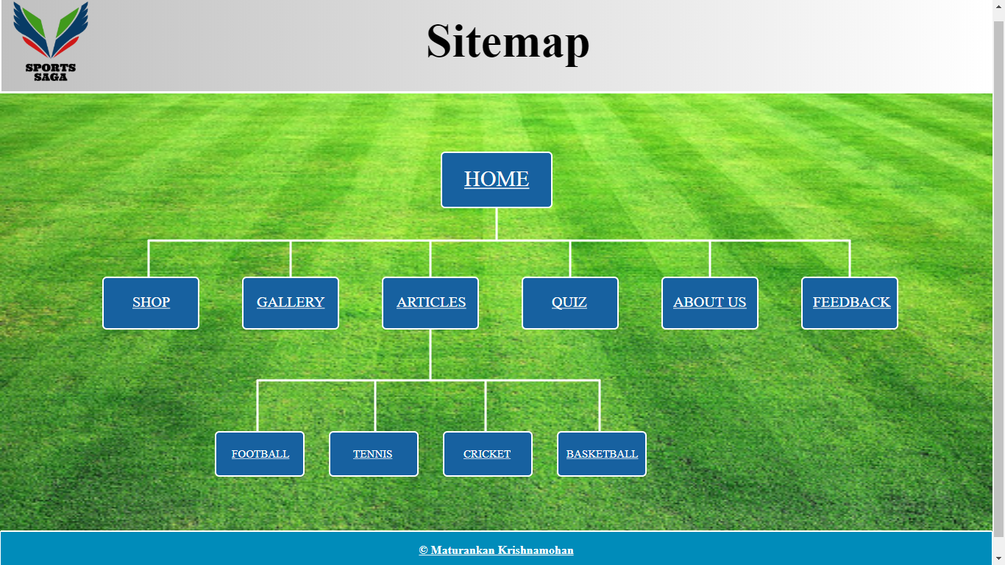

articles.html

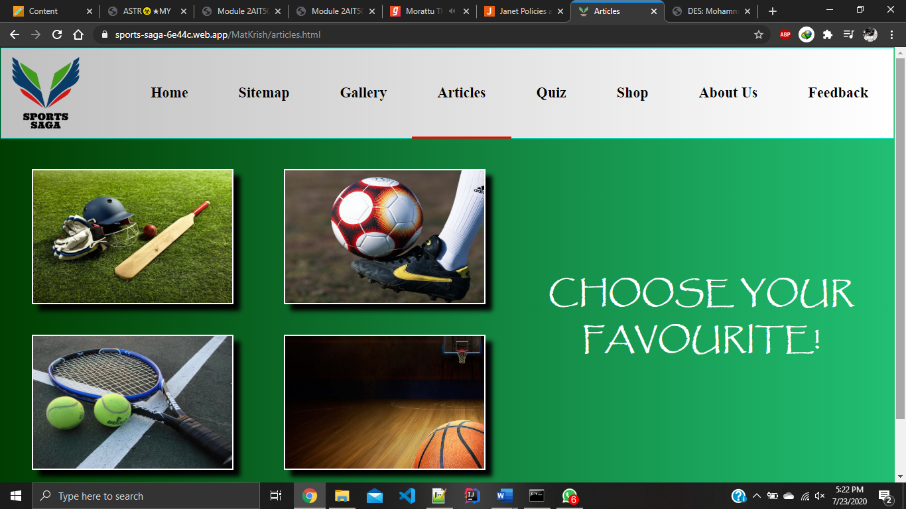

cricket.html

